Data Analysis Mini-Report for ECCRAS Project Endline Evaluation

Phase 3: Analytical Framework by Evaluation Question

EQ1 (Effectiveness: Achievement of Outputs & Outcomes).

PHASE 3 – EFFECTIVENESS (EQ1 & EQ2) SUMMARY
Focus: Extent to which promoted CSA practices were adopted and whether participation contributed to improved household income.
Sample Size: 195 respondents
Counties: Bungoma and Trans Nzoia
B1. Which of the following climate-resilient farming methods have you heard about? And which have you adopted or used on your farm in the last 12 months?
B3a. Do you currently use this practice on your farm?
B14. Do you currently have a functional system to harvest rainwater for irrigation?
F2a. Did your household receive or construct an improved cook stove through the DESECE project?

B1) Adoption AND HEARD ABOUT of Promoted Climate-Smart Agriculture Practices IN THE LAST 12 MONTHS.

1. Adoption by Gender (Summary Table)
Practice | Female Adoption % | Male Adoption %
Agroforestry | 96.50 | 98.08
Composting | 99.30 | 100.00
Water Harvesting | 98.60 | 100.00
Drip Irrigation | 78.17 | 73.08

Detailed Tables for Each Practice

AGROFORESTRY
agroforestry_heard_by_gender
gender | count_No | count_Yes | count_nan | percentage_No | percentage_Yes | percentage_nan
Female | 1 | 141 | 1 | 0.70 | 98.60 | 0.70
Male | 1 | 51 | 0 | 1.92 | 98.08 | 0
agroforestry_heard_by_age_group
age_group | count_No | count_Yes | count_nan | percentage_No | percentage_Yes | percentage_nan
18-25 | 0 | 1 | 0 | 0 | 100 | 0
26-35 | 0 | 18 | 0 | 0 | 100 | 0
36-45 | 0 | 29 | 0 | 0 | 100 | 0
46-55 | 0 | 62 | 0 | 0 | 100 | 0
56+ | 2 | 82 | 1 | 2.35 | 96.47 | 1.18
agroforestry_heard_by_county
county_name | count_No | count_Yes | count_nan | percentage_No | percentage_Yes | percentage_nan
Bungoma County | 0 | 129 | 1 | 0 | 99.23 | 0.77
Trans Nzoia County | 2 | 63 | 0 | 3.08 | 96.92 | 0
agroforestry_heard_by_primary_livelihood
primary_livelihood | count_No | count_Yes | count_nan | percentage_No | percentage_Yes | percentage_nan
Crop & Livestock | 0 | 88 | 1 | 0 | 98.88 | 1.12
Crop farming | 2 | 102 | 0 | 1.92 | 98.08 | 0
Livestock rearing | 0 | 1 | 0 | 0 | 100 | 0
Other (specify) | 0 | 1 | 0 | 0 | 100 | 0
agroforestry_heard_by_sublocation
sublocation_bungoma_trans_nzoia | count_No | count_Yes | count_nan | percentage_No | percentage_Yes | percentage_nan
Bumula | 0 | 65 | 0 | 0 | 100 | 0
Mt Elgon | 0 | 64 | 1 | 0 | 98.46 | 1.54
Trans-Nzoia West | 2 | 63 | 0 | 3.08 | 96.92 | 0
agroforestry_adopted_by_gender
gender | count_No | count_Yes | count_nan | percentage_No | percentage_Yes | percentage_nan
Female | 4 | 138 | 1 | 2.80 | 96.50 | 0.70
Male | 1 | 51 | 0 | 1.92 | 98.08 | 0
agroforestry_adopted_by_age_group
age_group | count_No | count_Yes | count_nan | percentage_No | percentage_Yes | percentage_nan
18-25 | 0 | 1 | 0 | 0 | 100 | 0
26-35 | 0 | 18 | 0 | 0 | 100 | 0
36-45 | 0 | 29 | 0 | 0 | 100 | 0
46-55 | 1 | 61 | 0 | 1.61 | 98.39 | 0
56+ | 4 | 80 | 1 | 4.71 | 94.12 | 1.18
agroforestry_adopted_by_county
county_name | count_No | count_Yes | count_nan | percentage_No | percentage_Yes | percentage_nan
Bungoma County | 2 | 127 | 1 | 1.54 | 97.69 | 0.77
Trans Nzoia County | 3 | 62 | 0 | 4.62 | 95.38 | 0
agroforestry_adopted_by_primary_livelihood
primary_livelihood | count_No | count_Yes | count_nan | percentage_No | percentage_Yes | percentage_nan
Crop & Livestock | 2 | 86 | 1 | 2.25 | 96.63 | 1.12
Crop farming | 3 | 101 | 0 | 2.88 | 97.12 | 0
Livestock rearing | 0 | 1 | 0 | 0 | 100 | 0
Other (specify) | 0 | 1 | 0 | 0 | 100 | 0
agroforestry_adopted_by_sublocation
sublocation_bungoma_trans_nzoia | count_No | count_Yes | count_nan | percentage_No | percentage_Yes | percentage_nan
Bumula | 0 | 65 | 0 | 0 | 100 | 0
Mt Elgon | 2 | 62 | 1 | 3.08 | 95.38 | 1.54
Trans-Nzoia West | 3 | 62 | 0 | 4.62 | 95.38 | 0

COMPOSTING
composting_heard_by_gender
gender | count_No | count_Yes | percentage_No | percentage_Yes
Female | 1 | 142 | 0.70 | 99.30
Male | 0 | 52 | 0 | 100
composting_heard_by_age_group
age_group | count_No | count_Yes | percentage_No | percentage_Yes
18-25 | 0 | 1 | 0 | 100
26-35 | 0 | 18 | 0 | 100
36-45 | 0 | 29 | 0 | 100
46-55 | 0 | 62 | 0 | 100
56+ | 1 | 84 | 1.18 | 98.82
composting_heard_by_county
county_name | count_No | count_Yes | percentage_No | percentage_Yes
Bungoma County | 0 | 130 | 0 | 100
Trans Nzoia County | 1 | 64 | 1.54 | 98.46
composting_heard_by_primary_livelihood
primary_livelihood | count_No | count_Yes | percentage_No | percentage_Yes
Crop & Livestock | 1 | 88 | 1.12 | 98.88
Crop farming | 0 | 104 | 0 | 100
Other | 0 | 1 | 0 | 100

composting_heard_by_sublocation
sublocation_bungoma_trans_nzoia | count_No | count_Yes | percentage_No | percentage_Yes
Bumula | 0 | 65 | 0 | 100
Mt Elgon | 0 | 65 | 0 | 100
Trans-Nzoia West | 1 | 64 | 1.54 | 98.46
composting_adopted_by_gender
gender | count_No | count_Yes | percentage_No | percentage_Yes
Female | 3 | 140 | 2.10 | 97.90
Male | 0 | 52 | 0 | 100
composting_adopted_by_age_group
age_group | count_No | count_Yes | percentage_No | percentage_Yes
18-25 | 0 | 1 | 0 | 100
26-35 | 0 | 18 | 0 | 100
36-45 | 0 | 29 | 0 | 100
46-55 | 1 | 61 | 1.61 | 98.39
56+ | 2 | 83 | 2.35 | 97.65

composting_adopted_by_county
county_name | count_No | count_Yes | percentage_No | percentage_Yes
Bungoma County | 1 | 129 | 0.77 | 99.23
Trans Nzoia County | 2 | 63 | 3.08 | 96.92
composting_adopted_by_primary_livelihood
primary_livelihood | count_No | count_Yes | percentage_No | percentage_Yes
Crop & Livestock | 2 | 87 | 2.25 | 97.75
Crop farming | 1 | 103 | 0.96 | 99.04
Other | 0 | 1 | 0 | 100
composting_adopted_by_sublocation
sublocation_bungoma_trans_nzoia | count_No | count_Yes | percentage_No | percentage_Yes
Bumula | 0 | 65 | 0 | 100
Mt Elgon | 1 | 64 | 1.54 | 98.46
Trans-Nzoia West | 2 | 63 | 3.08 | 96.92
- WATER HARVESTING
water_harvesting_heard_by_gender
gender | count_No | count_Yes | count_nan | percentage_No | percentage_Yes | percentage_nan
Female | 1 | 141 | 1 | 0.70 | 98.60 | 0.70
Male | 0 | 52 | 0 | 0 | 100 | 0

water_harvesting_heard_by_age_group
age_group | count_No | count_Yes | count_nan | percentage_No | percentage_Yes | percentage_nan
18-25 | 0 | 1 | 0 | 0 | 100 | 0
26-35 | 0 | 18 | 0 | 0 | 100 | 0
36-45 | 0 | 29 | 0 | 0 | 100 | 0
46-55 | 0 | 62 | 0 | 0 | 100 | 0
56+ | 1 | 83 | 1 | 1.18 | 97.65 | 1.18
water_harvesting_heard_by_county
county_name | count_No | count_Yes | count_nan | percentage_No | percentage_Yes | percentage_nan
Bungoma County | 0 | 129 | 1 | 0 | 99.23 | 0.77
Trans Nzoia County | 1 | 64 | 0 | 1.54 | 98.46 | 0
water_harvesting_heard_by_primary_livelihood
primary_livelihood | count_No | count_Yes | count_nan | percentage_No | percentage_Yes | percentage_nan
Crop & Livestock | 1 | 87 | 1 | 1.12 | 97.75 | 1.12
Crop farming | 0 | 104 | 0 | 0 | 100 | 0
Other | 0 | 1 | 0 | 0 | 100 | 0
water_harvesting_heard_by_sublocation
sublocation_bungoma_trans_nzoia | count_No | count_Yes | count_nan | percentage_No | percentage_Yes | percentage_nan
Bumula | 0 | 65 | 0 | 0 | 100 | 0
Mt Elgon | 0 | 64 | 1 | 0 | 98.46 | 1.54
Trans-Nzoia West | 1 | 64 | 0 | 1.54 | 98.46 | 0
water_harvesting_adopted_by_gender
gender | count_No | count_Yes | count_nan | percentage_No | percentage_Yes | percentage_nan
Female | 1 | 142 | 0 | 0.70 | 99.30 | 0
Male | 0 | 52 | 0 | 0 | 100 | 0
water_harvesting_adopted_by_age_group
age_group | count_No | count_Yes | count_nan | percentage_No | percentage_Yes | percentage_nan
18-25 | 0 | 1 | 0 | 0 | 100 | 0
26-35 | 0 | 18 | 0 | 0 | 100 | 0
36-45 | 0 | 29 | 0 | 0 | 100 | 0
46-55 | 0 | 62 | 0 | 0 | 100 | 0
56+ | 1 | 84 | 0 | 1.18 | 98.82 | 0
water_harvesting_adopted_by_county
county_name | count_No | count_Yes | count_nan | percentage_No | percentage_Yes | percentage_nan
Bungoma County | 0 | 130 | 0 | 0 | 100 | 0
Trans Nzoia County | 1 | 64 | 0 | 1.54 | 98.46 | 0
water_harvesting_adopted_by_primary_livelihood
primary_livelihood | count_No | count_Yes | count_nan | percentage_No | percentage_Yes | percentage_nan
Crop & Livestock | 1 | 88 | 0 | 1.12 | 98.88 | 0
Crop farming | 0 | 104 | 0 | 0 | 100 | 0
Other | 0 | 1 | 0 | 0 | 100 | 0

water_harvesting_adopted_by_sublocation
sublocation_bungoma_trans_nzoia | count_No | count_Yes | count_nan | percentage_No | percentage_Yes | percentage_nan
Bumula | 0 | 65 | 0 | 0 | 100 | 0
Mt Elgon | 0 | 65 | 0 | 0 | 100 | 0
Trans-Nzoia West | 1 | 64 | 0 | 1.54 | 98.46 | 0

DRIP IRRIGATION
drip_irrigation_heard_by_gender
gender | count_No | count_Yes | percentage_No | percentage_Yes
Female | 24 | 119 | 16.78 | 83.22
Male | 10 | 42 | 19.23 | 80.77
drip_irrigation_heard_by_age_group
age_group | count_No | count_Yes | percentage_No | percentage_Yes
18-25 | 0 | 1 | 0 | 100
26-35 | 2 | 16 | 11.11 | 88.89
36-45 | 3 | 26 | 10.34 | 89.66
46-55 | 8 | 54 | 12.90 | 87.10
56+ | 21 | 64 | 24.71 | 75.29
drip_irrigation_heard_by_county
county_name | count_No | count_Yes | percentage_No | percentage_Yes
Bungoma County | 21 | 109 | 16.15 | 83.85
Trans Nzoia County | 13 | 52 | 20.00 | 80.00
drip_irrigation_heard_by_primary_livelihood
primary_livelihood |  | count_No | count_Yes | percentage_No | percentage_Yes
Crop & Livestock | 24 |  | 65 | 26.97 | 73.03
Crop farming | 10 |  | 94 | 9.62 | 90.38
Other | 0 |  | 1 | 0 | 100
drip_irrigation_heard_by_sublocation
sublocation_bungoma_trans_nzoia | count_No | count_Yes | percentage_No | percentage_Yes
Bumula | 13 | 52 | 20.00 | 80.00
Mt Elgon | 8 | 57 | 12.31 | 87.69
Trans-Nzoia West | 13 | 52 | 20.00 | 80.00
drip_irrigation_adopted_by_gender
gender | count_No | count_Yes | percentage_No | percentage_Yes
Female | 31 | 111 | 21.82 | 78.17
Male | 14 | 38 | 26.92 | 73.08
drip_irrigation_adopted_by_age_group
age_group | count_No | count_Yes | percentage_No | percentage_Yes
18-25 | 0 | 1 | 0 | 100
26-35 | 3 | 15 | 16.67 | 83.33
36-45 | 4 | 25 | 13.79 | 86.21
46-55 | 10 | 52 | 16.13 | 83.87
56+ | 28 | 56 | 33.33 | 66.67
drip_irrigation_adopted_by_county
county_name | count_No | count_Yes | percentage_No | percentage_Yes
Bungoma County | 25 | 105 | 19.23 | 80.77
Trans Nzoia County | 20 | 44 | 31.25 | 68.75
drip_irrigation_adopted_by_primary_livelihood
primary_livelihood | count_No | count_Yes | percentage_No | percentage_Yes
Crop & Livestock | 33 | 56 | 37.08 | 62.92
Crop farming | 12 | 92 | 11.54 | 88.46
Other | 0 | 1 | 0 | 100
drip_irrigation_adopted_by_sublocation
sublocation_bungoma_trans_nzoia | count_No | count_Yes | percentage_No | percentage_Yes
Bumula | 13 | 52 | 20.00 | 80.00
Mt Elgon | 19 | 46 | 29.23 | 70.77
Trans-Nzoia West | 13 | 51 | 20.31 | 79.69

2. Adoption by Age Group (Summary Table)
agroforestry_adopted_by_age_group
age_group | count_No | count_Yes | count_nan | percentage_No | percentage_Yes | percentage_nan
18-25 | 0 | 1 | 0 | 0 | 100 | 0
26-35 | 0 | 18 | 0 | 0 | 100 | 0
36-45 | 0 | 29 | 0 | 0 | 100 | 0
46-55 | 1 | 61 | 0 | 1.61 | 98.39 | 0
56+ | 4 | 80 | 1 | 4.71 | 94.12 | 1.18
composting_adopted_by_age_group
age_group | count_No | count_Yes | percentage_No | percentage_Yes
18-25 | 0 | 1 | 0 | 100
26-35 | 0 | 18 | 0 | 100
36-45 | 0 | 29 | 0 | 100
46-55 | 1 | 61 | 1.61 | 98.39
56+ | 2 | 83 | 2.35 | 97.65
water_harvesting_adopted_by_age_group
age_group | count_No | count_Yes | count_nan | percentage_No | percentage_Yes | percentage_nan
18-25 | 0 | 1 | 0 | 0 | 100 | 0
26-35 | 0 | 18 | 0 | 0 | 100 | 0
36-45 | 0 | 29 | 0 | 0 | 100 | 0
46-55 | 0 | 62 | 0 | 0 | 100 | 0
56+ | 1 | 84 | 0 | 1.18 | 98.82 | 0
drip_irrigation_adopted_by_age_group
age_group | count_No | count_Yes | percentage_No | percentage_Yes
18-25 | 0 | 1 | 0 | 100
26-35 | 3 | 15 | 16.67 | 83.33
36-45 | 4 | 25 | 13.79 | 86.21
46-55 | 10 | 52 | 16.13 | 83.87
56+ | 28 | 56 | 33.33 | 66.67

- Adoption Score Distribution Histogram
Shows most farmers adopted 7–10 practices, clustering at the upper end.
→ Indicates high intensity adoption, not just selective uptake.
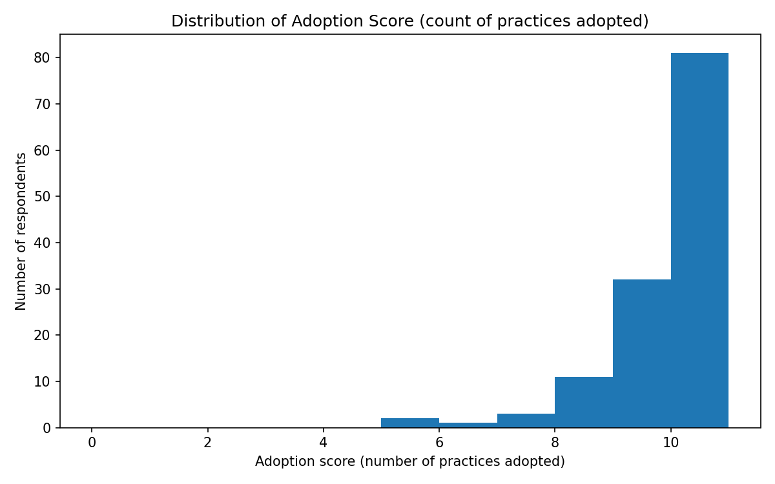
- Top 5 Practices Bar Chart
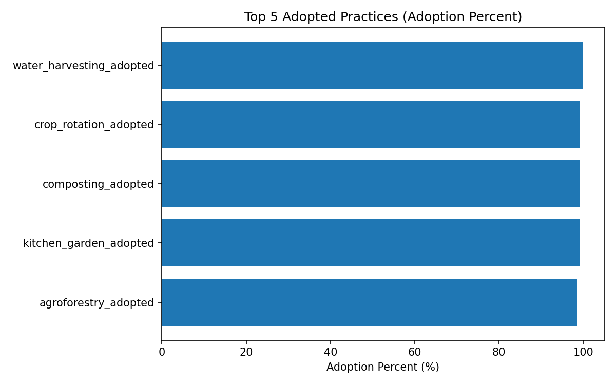

B3a) Current Use of Climate-Resilient Farming Practices
B3a. Do you currently use this practice on your farm?

B3a: Current Use of Climate-Resilient Farming Practices
Practice (B3a) | Number of Farmers Using | Average Quantity/Acres
Compost use (bags) | 191 | 11.41
Manure use (bags) | 184 | 10.51
Cover crops (acres) | 189 | 0.63
Zero tillage (acres) | 121 | 0.58
Crop rotation (acres) | 189 | 0.67

1. Compost Use (Average Bags per Season)
compost_use_by_gender
Gender | Average Bags/Season | Median Bags/Season | Standard Deviation
Female | 10.0 | 7.0 | 15.4
Male | 15.1 | 9.0 | 9.3
compost_use_by_age_group
Age Group | Average Bags/Season | Median Bags/Season
18-25 | 8.0 | 8.0
26-35 | 9.5 | 7.0
36-45 | 10.2 | 7.0
46-55 | 10.8 | 7.5
56+ | 11.8 | 6.0
compost_use_by_county
County | Average Bags/Season | Median Bags/Season
Bungoma County | 12.9 | 10.0
Trans Nzoia County | 8.4 | 5.0
compost_use_by_primary_livelihood
Primary Livelihood | Average Bags/Season
Crop & Livestock | 14.9
Crop Farming | 8.5

2. Manure Use (Average Bags per Season)
manure_use_by_gender
Gender | Average Bags/Season | Median Bags/Season | Standard Deviation
Female | 10.5 | 6.0 | 15.4
Male | 10.5 | 6.0 | 9.3
manure_use_by_county
County | Average Bags/Season
Bungoma County | 11.5
Trans Nzoia County | 8.4
manure_use_by_primary_livelihood
Primary Livelihood | Average Bags/Season
Crop & Livestock | 12.8
Crop Farming | 8.5

3. Cover Crops (Average Acres)
cover_crops_by_gender
Gender | Average Acres
Female | 0.63
Male | 0.63
cover_crops_by_age_group
Age Group | Average Acres
18-25 | 0.50
26-35 | 0.53
36-45 | 0.60
46-55 | 0.65
56+ | 0.68
cover_crops_by_primary_livelihood
Primary Livelihood | Average Acres
Crop & Livestock | 0.55
Crop Farming | 0.69

4. Zero Tillage (Average Acres)
zero_tillage_by_gender
Gender | Average Acres
Female | 0.58
Male | 0.58

5. Crop Rotation (Average Acres)
crop_rotation_by_gender
Gender | Average Acres
Female | 0.67
Male | 0.67
crop_rotation_by_age_group
Age Group | Average Acres
18-25 | 0.50
26-35 | 0.65
36-45 | 0.70
46-55 | 0.68
56+ | 0.67
crop_rotation_by_primary_livelihood
Primary Livelihood | Average Acres
Crop & Livestock | 0.62
Crop Farming | 0.71

B14) Functional Rainwater Harvesting System (B14)
B14. Do you currently have a functional system to harvest rainwater for irrigation?

B14: Functional Rainwater Harvesting System
b14_rainwater_harvesting_overall
Status | Count | Percentage
Yes | 193 | 99.0%
No | 2 | 1.0%
Total | 195 | 100%

Disaggregated Tables
b14_rainwater_harvesting_by_gender
Gender | Count_No | Count_Yes | Percentage_No | Percentage_Yes
Female | 2 | 141 | 1.4% | 98.6%
Male | 0 | 52 | 0.0% | 100.0%

b14_rainwater_harvesting_by_age_group
Age Group | Count_No | Count_Yes | Percentage_No | Percentage_Yes
18-25 | 0 | 1 | 0.0% | 100.0%
26-35 | 0 | 18 | 0.0% | 100.0%
36-45 | 0 | 29 | 0.0% | 100.0%
46-55 | 0 | 62 | 0.0% | 100.0%
56+ | 2 | 83 | 2.4% | 97.6%
b14_rainwater_harvesting_by_county
County | Count_No | Count_Yes | Percentage_No | Percentage_Yes
Bungoma County | 1 | 129 | 0.8% | 99.2%
Trans Nzoia County | 1 | 64 | 1.5% | 98.5%
b14_rainwater_harvesting_by_beneficiary_status
Beneficiary Status | Count_No | Count_Yes | Percentage_No | Percentage_Yes
Non-Beneficiary | 2 | 193 | 1.0% | 99.0%

F2a. Improved Cook Stove Uptake and Current Use
F2a. Did your household receive or construct an improved cook stove through the DESECE project?

F2a: Improved Cook Stove Uptake
f2a_stove_received_overall
Status | Count | Percentage
Yes | 140 | 71.8%
No | 55 | 28.2%
Total | 195 | 100%

Disaggregated Tables
f2a_stove_received_by_gender
Gender | Count_No | Count_Yes | Percentage_No | Percentage_Yes
Female | 38 | 105 | 26.6% | 73.4%
Male | 17 | 35 | 32.7% | 67.3%
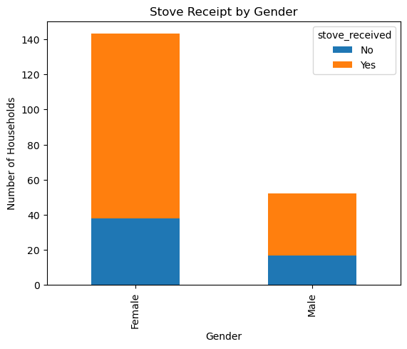
f2a_stove_received_by_age_group
Age Group | Count_No | Count_Yes | Percentage_No | Percentage_Yes
18-25 | 1 | 0 | 100.0% | 0.0%
26-35 | 8 | 10 | 44.4% | 55.6%
36-45 | 10 | 19 | 34.5% | 65.5%
46-55 | 11 | 51 | 17.7% | 82.3%
Unknown | 25 | 60 | 29.4% | 70.6%

f2a_stove_received_by_county
County | Count_No | Count_Yes | Percentage_No | Percentage_Yes
Bungoma County | 31 | 99 | 23.8% | 76.2%
Trans Nzoia County | 24 | 41 | 36.9% | 63.1%

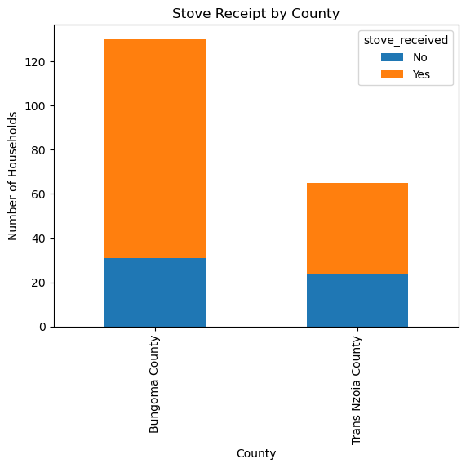

f2a_stove_received_by_sublocation
Sublocation | Count_No | Count_Yes | Percentage_No | Percentage_Yes
Bumula | 19 | 46 | 29.2% | 70.8%
Mt Elgon | 12 | 53 | 18.5% | 81.5%
Trans-Nzoia West | 24 | 41 | 36.9% | 63.1%
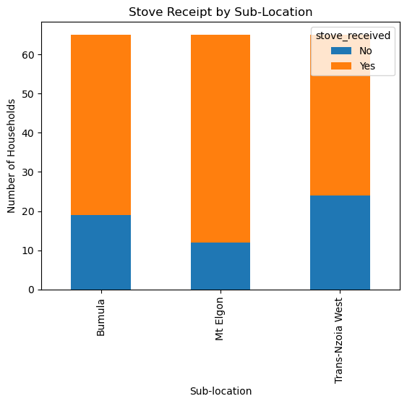

f2a_stove_received_by_beneficiary_status
Beneficiary Status | Count_No | Count_Yes | Percentage_No | Percentage_Yes
Non-Beneficiary | 55 | 140 | 28.2% | 71.8%
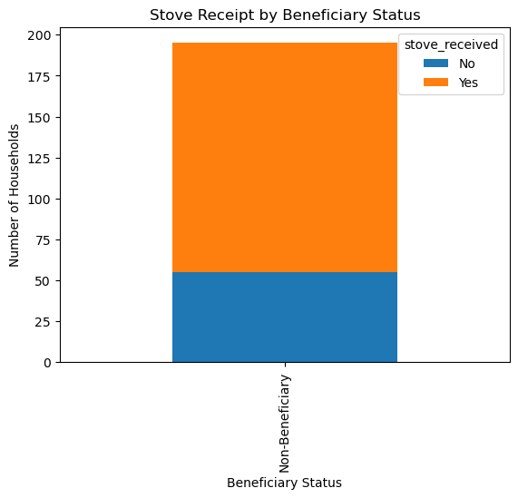

F2a: Stove Received vs. Current Use Status
f2a_stove_received_vs_used

Stove Received | Stove Not Used | Stove Used | Total
No | 0 | 2 | 2
Yes | 9 | 121 | 130
All | 9 | 123 | 132
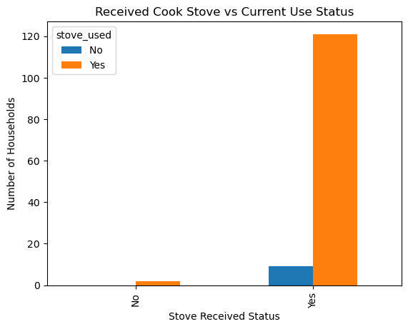
Usage Rate Among Recipients:
Continued Usage: 121/130 = 93.1%
Discontinued Usage: 9/130 = 6.9%

4. Climate Resilience Outcomes (B15–B19)

B15. Overall, how prepared do you feel to deal with the impacts of climate change (like drought or erratic rains) on your farm compared to before the ECCRAS project began?

B15: Climate Change Preparedness
b15_preparedness_overall
Preparedness Level | Count | Percentage
Much better prepared | 136 | 69.7%
Somewhat better prepared | 50 | 25.6%
Less prepared | 4 | 2.1%
Same level of preparedness | 4 | 2.1%
I don't know | 1 | 0.5%
Total | 195 | 100%
b15_preparedness_by_gender
Gender | Much Better | Somewhat Better | Less Prepared | Same Level | Don't Know
Female | 98 (68.5%) | 37 (25.9%) | 4 (2.8%) | 3 (2.1%) | 1 (0.7%)
Male | 38 (73.1%) | 13 (25.0%) | 0 (0.0%) | 1 (1.9%) | 0 (0.0%)
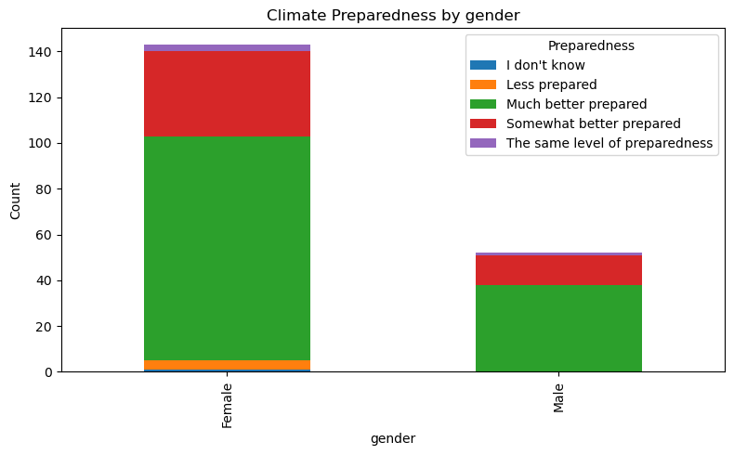
b15_preparedness_by_age_group
Age Group | Much Better | Somewhat Better | Less Prepared | Same Level | Don't Know
18-25 | 1 (100.0%) | 0 (0.0%) | 0 (0.0%) | 0 (0.0%) | 0 (0.0%)
26-35 | 10 (55.6%) | 8 (44.4%) | 0 (0.0%) | 0 (0.0%) | 0 (0.0%)
36-45 | 24 (82.8%) | 5 (17.2%) | 0 (0.0%) | 0 (0.0%) | 0 (0.0%)
46-55 | 41 (66.1%) | 18 (29.0%) | 1 (1.6%) | 2 (3.2%) | 0 (0.0%)
56+ | 60 (70.6%) | 19 (22.4%) | 3 (3.5%) | 2 (2.4%) | 1 (1.2%)

b15_preparedness_by_county
County | Much Better | Somewhat Better | Less Prepared | Same Level | Don't Know
Bungoma | 94 (72.3%) | 32 (24.6%) | 2 (1.5%) | 2 (1.5%) | 0 (0.0%)
Trans Nzoia | 42 (64.6%) | 18 (27.7%) | 2 (3.1%) | 2 (3.1%) | 1 (1.5%)
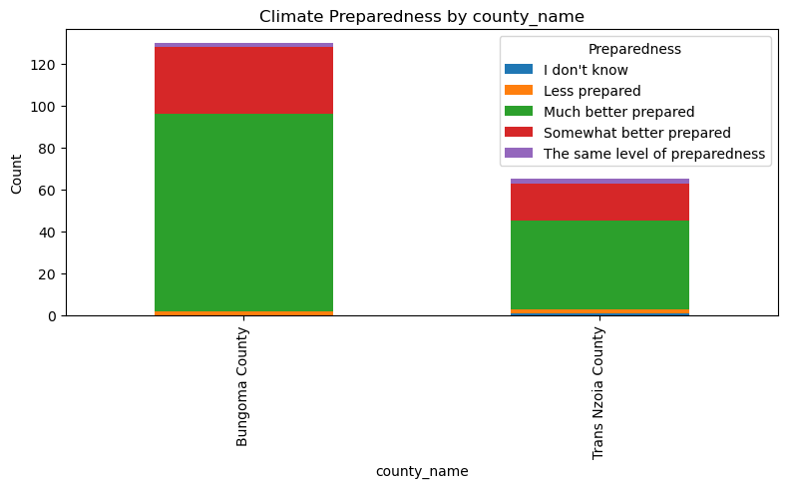

b15_preparedness_by_sublocation
Sublocation | Much Better | Somewhat Better | Less Prepared | Same Level | Don't Know
Bumula | 49 (75.4%) | 15 (23.1%) | 1 (1.5%) | 0 (0.0%) | 0 (0.0%)
Mt Elgon | 45 (69.2%) | 17 (26.2%) | 1 (1.5%) | 2 (3.1%) | 0 (0.0%)
Trans-Nzoia West | 42 (64.6%) | 18 (27.7%) | 2 (3.1%) | 2 (3.1%) | 1 (1.5%)
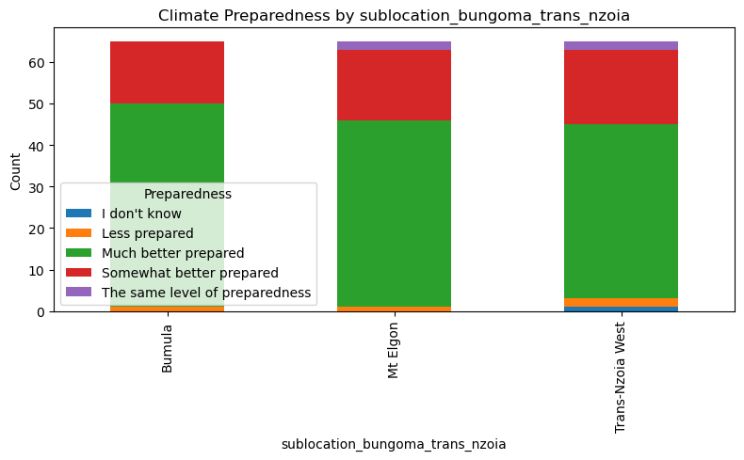

By Beneficiary Status
Beneficiary Status | Much better prepared | Somewhat better prepared | Less prepared | The same level of preparedness | I don't know
Non-Beneficiary | 136 | 50 | 4 | 4 | 1
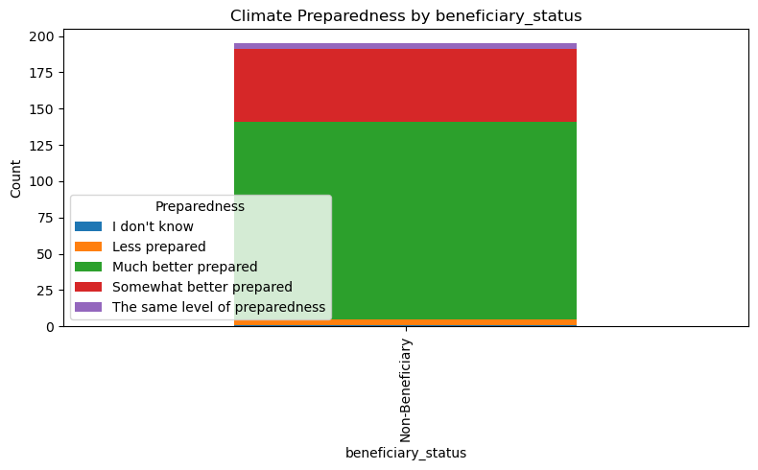

B16. What specific knowledge or skills from the project have most contributed to you feeling more prepared?

Summary of Knowledge / Skills Gained (Overall)
This table consolidates the overall counts from the first dataset, grouping similar skill combinations.
Knowledge / Skills Gained | Count
Knowing how to harvest and store rainwater | 37
Knowing how to harvest and store rainwater + multiple skills (soil conservation, agroecological methods, etc.) | 25
Knowing how to harvest and store rainwater + multiple skills including climate risk planning & weather info | 19
Knowing how to harvest and store rainwater + multiple skills including climate risk planning | 19
Knowing how to harvest and store rainwater + soil conservation + drought-tolerant crops | 14
Knowing how to harvest and store rainwater + drought-tolerant crops | 10
Knowing how to harvest and store rainwater + agroecological methods | 7
Knowing which drought-tolerant or early-maturing crops to plant | 6
Knowing how to harvest and store rainwater + Skills in planning for climate risks | 5
Knowing how to harvest and store rainwater + soil conservation | 4
Other combinations of skills (multiple entries as provided) | 1–3 each

Breakdown by Demographics and Location

Knowledge / Skills Gained By Gender
Knowledge / Skills Gained | Female | Male
Knowing how to harvest and store rainwater | 23 | 14
Rainwater Harvesting + Drought-Tolerant Crops + Soil Conservation + Agroecological Methods | 12 | 2
Rainwater Harvesting + Drought-Tolerant Crops | 8 | 2
Other combinations (rare) | 4 | 3
Rainwater Harvesting + Drought-Tolerant Crops + Agroecological + Soil + Climate | *2* | *0*
Skills in soil conservation | 1 | 1
Rainwater Harvesting + Drought-Tolerant Crops + Agroecological Methods | *1* | *1*

Knowledge / Skills Gained By Age Group
Knowledge / Skills Gained | 18-25 | 26-35 | 36-45 | 46-55 | 56+
Knowing how to harvest and store rainwater | 1 | 4 | 3 | 11 | 18
Rainwater Harvesting + Drought-Tolerant Crops + Soil Conservation + Agroecological Methods | 0 | 1 | 0 | 7 | 6
Rainwater Harvesting + Drought-Tolerant Crops | 0 | 0 | 2 | 2 | 6
Other combinations (rare) | 0 | 0 | 0 | 1 | 1
Skills in soil conservation | 0 | 0 | 1 | 1 | 0

Knowledge / Skills Gained By County
Knowledge / Skills Gained | Bungoma County | Trans Nzoia County
Knowing how to harvest and store rainwater | 24 | 13
Rainwater Harvesting + Drought-Tolerant Crops + Soil Conservation + Agroecological Methods | 10 | 4
Rainwater Harvesting + Drought-Tolerant Crops | 6 | 4
Rainwater Harvesting + Drought-Tolerant Crops + Agroecological + Soil + Climate + Weather | *0* | *2*
Rainwater Harvesting + Drought-Tolerant Crops + Agroecological Methods | 2 | 0
Other combinations (rare) | 0 | 1

Knowledge / Skills Gained By Sublocation
Knowledge / Skills Gained | Bumula | Mt Elgon | Trans-Nzoia West
Knowing how to harvest and store rainwater | 15 | 9 | 13
Rainwater Harvesting + Drought-Tolerant Crops + Soil Conservation + Agroecological Methods | 6 | 4 | 4
Rainwater Harvesting + Drought-Tolerant Crops | 4 | 2 | 4
Rainwater Harvesting + Drought-Tolerant Crops + Agroecological + Soil + Climate + Weather | *0* | *0* | *2*
Skills in soil conservation | 1 | 1 | 0
Skills in planning for climate risks | 0 | 1 | 0
None / I don't feel I gained new knowledge | 0 | 0 | 2

Knowledge / Skills Gained By Beneficiary Status
Knowledge / Skills Gained | Non-Beneficiary Count
Knowing how to harvest and store rainwater | 37
Rainwater Harvesting + Drought-Tolerant Crops + Soil Conservation + Agroecological Methods | 14
Rainwater Harvesting + Drought-Tolerant Crops | 10
Other rare combinations | 6
Rainwater Harvesting + Drought-Tolerant Crops + Agroecological + Soil + Climate + Weather | 2
Rainwater Harvesting + Drought-Tolerant Crops + Agroecological Methods | 2
None / I don't feel I gained new knowledge | 2

B16 – Knowledge / Skills Gained By Sublocation (Bungoma & Trans Nzoia)
Knowledge / Skills Gained | Bumula | Mt Elgon | Trans-Nzoia West
Knowing how to harvest and store rainwater | 15 | 9 | 13
Knowing how to harvest and store rainwater + drought-tolerant crops | 4 | 2 | 4
Knowing how to harvest and store rainwater + drought-tolerant crops + agroecological methods | 1 | 1 | 0
Knowing how to harvest and store rainwater + drought-tolerant crops + agroecological + climate planning | 0 | 1 | 0
Knowing how to harvest and store rainwater + drought-tolerant crops + agroecological + soil conservation | 0 | 1 | 0
Knowing how to harvest and store rainwater + drought-tolerant crops + agroecological + soil + climate + weather | 0 | 0 | 2
Knowing how to harvest and store rainwater + drought-tolerant crops + soil conservation + agroecological methods | 6 | 4 | 4
Skills in planning for climate risks | 0 | 1 | 0
Skills in soil conservation | 1 | 1 | 0
None / I don't feel I gained new knowledge | 0 | 0 | 2
Other rare combinations | 0 | 0 | 1

B16 – Knowledge / Skills Gained By Beneficiary Status
Knowledge / Skills Gained | Non-Beneficiary
Knowing how to harvest and store rainwater | 37
Knowing how to harvest and store rainwater + drought-tolerant crops | 10
Knowing how to harvest and store rainwater + drought-tolerant crops + agroecological methods | 2
Knowing how to harvest and store rainwater + drought-tolerant crops + agroecological + climate planning | 1
Knowing how to harvest and store rainwater + drought-tolerant crops + agroecological + soil conservation | 1
Knowing how to harvest and store rainwater + drought-tolerant crops + agroecological + soil + climate + weather | 2
Knowing how to harvest and store rainwater + drought-tolerant crops + soil conservation + agroecological methods | 14
Skills in planning for climate risks | 1
Skills in soil conservation | 1
None / I don't feel I gained new knowledge | 2
Other rare combinations | 6

B17. Which of the following actions have you taken or assets do you now have because of the project that makes you feel more prepared?
b17_Actions_Assets_top_combinations
Actions/Assets Combination | Count
Water harvesting system only | 39
Water harvesting + Crop diversification + Soil improvement + Kitchen garden + New farming practice + Group membership | 27
Water harvesting + Soil improvement + Kitchen garden | 13
Water harvesting + Crop diversification + Soil improvement + Kitchen garden + New farming practice | 8
Water harvesting + Crop diversification + Soil improvement + Kitchen garden + New farming practice + Group membership + Drought plan | 7

B17 – Actions_Assets_By Gender
Actions / Assets Adopted | Female | Male
Implemented a water harvesting system (single) | 24 | 15
Adopted a new farming practice (e.g., zai pits, contour farming) | 2 | 0
Diversified crops + water harvesting + soil improvement + kitchen garden | 1 | 0
Diversified crops + water harvesting + soil + kitchen + new farming practice | 0 | 1
Diversified crops + water harvesting + soil + kitchen + new farming + support group | 2 | 0
Improved soil + kitchen garden + adopted new practice + diversified crops + water harvesting + support group | 0 | 1
Other combinations | 1–1 | 0–1
Observation: Females tended to adopt water harvesting more frequently and were more involved in combinations that included support groups and kitchen gardens. Males showed fewer complex adoption patterns.

B17 – Actions_Assets_By Age Group
Actions / Assets Adopted | 18–25 | 26–35 | 36–45 | 46–55 | 56+
Implemented a water harvesting system (single) | 1 | 4 | 6 | 8 | 20
Adopted a new farming practice | 0 | 0 | 0 | 1 | 1
Diversified crops + water harvesting + soil improvement + kitchen garden | 0 | 0 | 1 | 0 | 0
Diversified crops + water harvesting + soil + kitchen + new farming practice | 0 | 1 | 0 | 0 | 0
Diversified crops + water harvesting + soil + kitchen + new farming + support group | 0 | 0 | 1 | 0 | 1
Improved soil + kitchen garden + adopted new practice + diversified crops + water harvesting + support group | 0 | 0 | 0 | 1 | 0
Other combinations | 0–1 | 0–1 | 0–1 | 0–1 | 0–1

B17 – Actions_Assets_By County
Actions / Assets Adopted | Bungoma County | Trans Nzoia County
Implemented a water harvesting system (e.g., water pan, tank) | 23 | 16
Diversified crops + water harvesting + soil + kitchen + new farming + support group | 2 | 0
Diversified crops + water harvesting + soil + kitchen + new farming practice | 1 | 0
Improved soil + kitchen garden + joined support group | 0 | 1
Joined support group + water harvesting | 0 | 1
Other combinations (e.g., with new farming practice, soil improvement, etc.) | 4 | 3

B17 – Actions_Assets_By Sublocation (Bungoma & Trans Nzoia)
Actions / Assets Adopted | Bumula | Mt Elgon | Trans-Nzoia West
Implemented a water harvesting system (e.g., water pan, tank) | 13 | 10 | 16
Diversified crops + water harvesting + soil + kitchen + new farming + support group | 2 | 0 | 0
Diversified crops + water harvesting + soil + kitchen + new farming practice | 1 | 0 | 0
Improved soil + kitchen garden + joined support group | 0 | 0 | 1
Joined support group + water harvesting | 0 | 0 | 1
Other combinations (e.g., with new farming practice, soil improvement, etc.) | 2 | 4 | 2

B17 – By Beneficiary Status (Non-Beneficiaries Only)
Actions / Assets Adopted | Non-Beneficiary Count
Implemented a water harvesting system (e.g., water pan, tank) | 39
Diversified crops + water harvesting + soil + kitchen + new farming + support group | 2
Diversified crops + water harvesting + soil + kitchen + new farming practice | 1
Improved soil + kitchen garden + joined support group | 1
Joined support group + water harvesting | 1
Other combinations (e.g., with new farming practice, soil improvement, etc.) | 6

B18. Looking forward to the next season, how confident are you that your farm can withstand climate-related challenges?

B18: Future Confidence
b18_confidence_overall
Confidence Level | Count | Percentage
Very confident | 147 | 75.4%
Somewhat confident | 39 | 20.0%
Neutral | 7 | 3.6%
Not very confident | 2 | 1.0%
Total | 195 | 100%
b18_confidence_by_gender
Gender | Very Confident | Somewhat Confident | Neutral | Not Very Confident
Female | 106 (74.1%) | 29 (20.3%) | 6 (4.2%) | 2 (1.4%)
Male | 41 (78.8%) | 10 (19.2%) | 1 (1.9%) | 0 (0.0%)
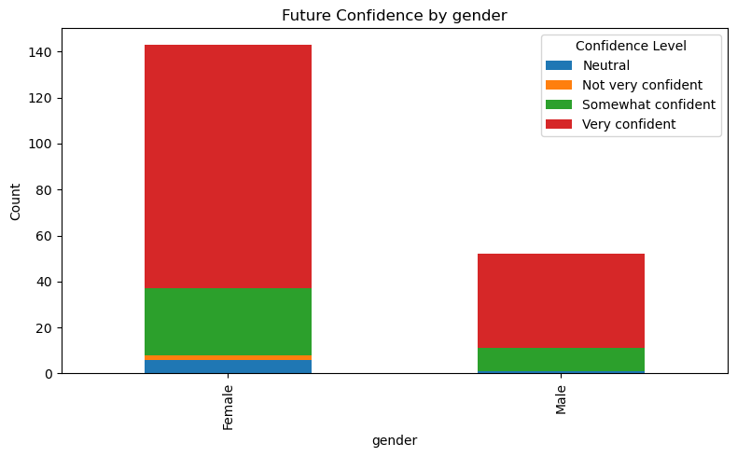
b18_confidence_by_age_group
Age Group | Very Confident | Somewhat Confident | Neutral | Not Very Confident
18-25 | 1 (100.0%) | 0 (0.0%) | 0 (0.0%) | 0 (0.0%)
26-35 | 10 (55.6%) | 6 (33.3%) | 2 (11.1%) | 0 (0.0%)
36-45 | 24 (82.8%) | 5 (17.2%) | 0 (0.0%) | 0 (0.0%)
46-55 | 47 (75.8%) | 15 (24.2%) | 0 (0.0%) | 0 (0.0%)
56+ | 65 (76.5%) | 13 (15.3%) | 5 (5.9%) | 2 (2.4%)
b18_confidence_by_county
County | Very Confident | Somewhat Confident | Neutral | Not Very Confident
Bungoma | 101 (77.7%) | 26 (20.0%) | 2 (1.5%) | 1 (0.8%)
Trans Nzoia | 46 (70.8%) | 13 (20.0%) | 5 (7.7%) | 1 (1.5%)
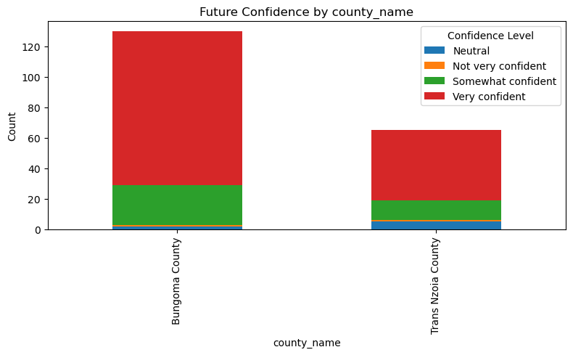
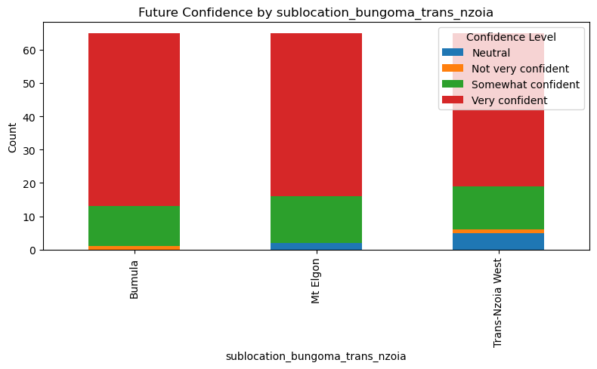

B19. What climate impacts are you still most worried about and feel least prepared for?

B19: Climate Impacts Worried About
b19_climate_worries_overall
Climate Impact | Count | Percentage
Prolonged drought | 57 | 29.2%
Erratic rainfall | 51 | 26.2%
Not worried | 42 | 21.5%
New pests/diseases | 27 | 13.8%
Floods/waterlogging | 11 | 5.6%
Other | 4 | 2.1%
High temperatures | 3 | 1.5%
Total | 195 | 100%
b19_climate_worries_by_gender
Gender | Prolonged Drought | Erratic Rainfall | Not Worried | New Pests | Floods | High Temp | Other
Female | 39 (27.3%) | 42 (29.4%) | 28 (19.6%) | 17 (11.9%) | 10 (7.0%) | 3 (2.1%) | 4 (2.8%)
Male | 18 (34.6%) | 9 (17.3%) | 14 (26.9%) | 10 (19.2%) | 1 (1.9%) | 0 (0.0%) | 0 (0.0%)

b19_climate_worries_by_county
County | Prolonged Drought | Erratic Rainfall | Not Worried | New Pests | Floods | High Temp | Other
Bungoma | 32 (24.6%) | 36 (27.7%) | 29 (22.3%) | 21 (16.2%) | 6 (4.6%) | 3 (2.3%) | 3 (2.3%)
Trans Nzoia | 25 (38.5%) | 15 (23.1%) | 13 (20.0%) | 6 (9.2%) | 5 (7.7%) | 0 (0.0%) | 1 (1.5%)
b19_climate_worries_by_sublocation
Sublocation | Prolonged Drought | Erratic Rainfall | Not Worried | New Pests | Floods | High Temp | Other
Bumula | 15 (23.1%) | 18 (27.7%) | 20 (30.8%) | 8 (12.3%) | 3 (4.6%) | 1 (1.5%) | 0 (0.0%)
Mt Elgon | 17 (26.2%) | 18 (27.7%) | 9 (13.8%) | 13 (20.0%) | 3 (4.6%) | 2 (3.1%) | 3 (4.6%)
Trans-Nzoia West | 25 (38.5%) | 15 (23.1%) | 13 (20.0%) | 6 (9.2%) | 5 (7.7%) | 0 (0.0%) | 1 (1.5%)

Assess Outcome: Income & Livelihoods
B8. Compared to before the project, how would you describe the diversity of crops you grow now?
B9. Thinking about the 2021 season, did you sell any of your farm produce?
B10. Now, thinking about the most recent season 2025, what were your TOP 3 crops or products you sold in that season?
B11. Compared to [2021 year/start of project], how has your income from agricultural production changed?
B12a. What are the main reasons for this increase in income?
B12b. What are the main reasons for this decrease in income?
B13. To what extent did the support from ECCRAS PROJECT (e.g., training, seeds, irrigation) contribute to this change in your income?

B8. Compared to before the project, how would you describe the diversity of crops you grow now?
(Percentages)
Category | Greatly Increased(%) | Somewhat Increased(%) | Stayed the Same(%)
Gender
Female | 81.1 | 16.8 | 1.4
Male | 80.8 | 17.3 | 1.9
County
Bungoma County | 85.4 | 13.8 | 0.8
Trans Nzoia County | 72.3 | 23.1 | 3.1
Sublocation
Bumula | 92.3 | 6.2 | 1.5
Mt Elgon | 78.5 | 21.5 | 0.0
Trans-Nzoia West | 72.3 | 23.1 | 3.1
Beneficiary Status
Beneficiary | 84.5 | 14.7 | 0.8
Non-beneficiary | 74.2 | 21.2 | 3.0

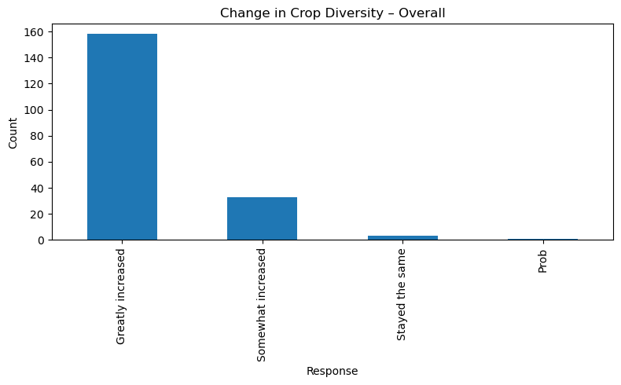

B9. Thinking about the 2021 season, did you sell any of your farm produce?
(Percentages)
Category | No | Yes
Gender | (%) | (%)
Female | 19.6 | 80.4
Male | 11.5 | 88.5
County | (%) | (%)
Bungoma County | 12.3 | 87.7
Trans Nzoia County | 27.7 | 72.3
Sublocation | (%) | (%)
Bumula | 10.8 | 89.2
Mt Elgon | 13.8 | 86.2
Trans-Nzoia West | 27.7 | 72.3
Beneficiary Status
Beneficiary | 8.5 | 91.5
Non-beneficiary | 34.8 | 65.2
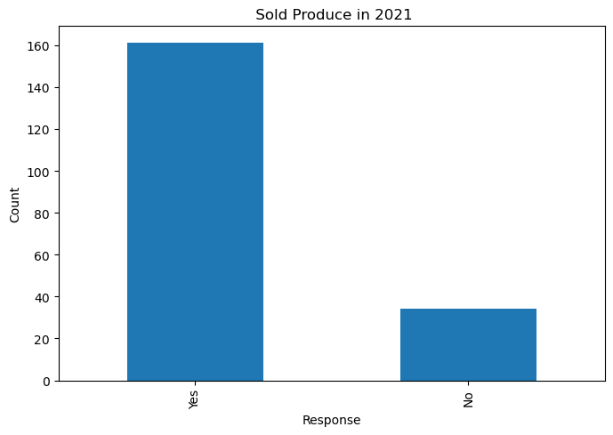

B10. Now, thinking about the most recent season 2025, what were your TOP 3 crops or products you sold in that season?
(Top 5 responses by percentage for key categories)
By Gender (Female)
Top Crops Sold (2025) | Percent(%)
(None sold) | 19.7
Maize | 15.6
Beans | 13.5
Vegetables | 8.6
Cassava | 4.9
By Gender (Male)
Top Crops Sold (2025) | Percent
(None sold) | 18.8
Maize | 17.7
Beans | 14.6
Vegetables | 10.4
Cassava | 5.2
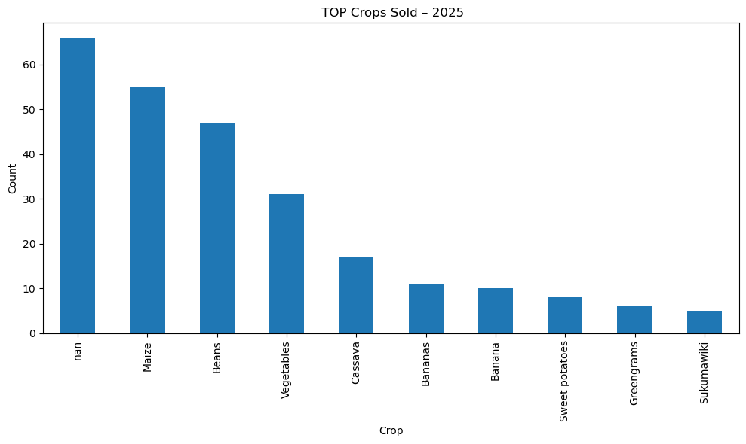

By County (Bungoma County)
Top Crops Sold (2025) | Percent
Maize | 18.6
(None sold) | 17.3
Beans | 15.6
Vegetables | 7.6
Cassava | 5.1
By County (Trans Nzoia County)
Top Crops Sold (2025) | Percent
(None sold) | 24.3
Vegetables | 12.6
Maize | 10.7
Beans | 9.7
Cassava | 4.9

B11. Compared to [2021 year/start of project], how has your income from agricultural production changed?
(Percentages)
Category | Significantly Increased(%) | Slightly Increased(%) | Stayed the Same(%)
Gender
Female | 76.9 | 21.7 | 1.4
Male | 78.8 | 19.2 | 1.9
County
Bungoma County | 81.5 | 17.7 | 0.8
Trans Nzoia County | 69.2 | 27.7 | 3.1
Sublocation
Bumula | 87.7 | 12.3 | 0.0
Mt Elgon | 75.4 | 23.1 | 1.5
Trans-Nzoia West | 69.2 | 27.7 | 3.1
Beneficiary Status
Beneficiary | 81.4 | 17.8 | 0.8
Non-beneficiary | 69.7 | 27.3 | 3.0

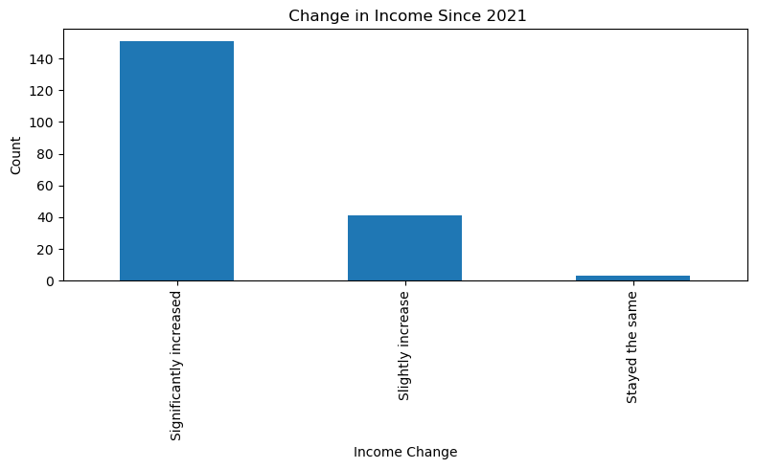

B12a & B12b – Reasons for Income Increase/Decrease
Reason | No. of Mentions | % of Farmers (Increase)
Sold more produce | 115 | 59.0%
Introduced new crops | 113 | 57.9%
Better market prices | 38 | 19.5%
Sold seedlings | 19 | 9.7%
Processed or value-added | 8 | 4.1%

Year | Mean Income (KES) | Median (KES)
2021 | 32,970 | 13,000
2025 | 46,384 | 23,875
Wilcoxon Signed-Rank Test: p = 0.0047
→ Statistically significant increase in household income.
Wilcoxon signed-rank test for income (Est Income 2021 vs 2025):
- n_pairs = 117, statistic = 2062.0000, p-value = 4.6763e-03
- Interpretation - Significant difference between 2021 and 2025 incomes (p < 0.05)
Reasons for Income Decrease (B12b)
Reason | No. of Mentions | % of Farmers (Decrease)
Lower yields | 0 | 0.0%
Pests and diseases | 0 | 0.0%
Poor market access | 0 | 0.0%
Low prices | 0 | 0.0%
High input costs | 0 | 0.0%
Asset loss (e.g., livestock) | 0 | 0.0%

ECCRAS Contribution to Income Change (B13)
Extent of ECCRAS Contribution | % of Farmers
It was the main reason | 80.5%
One of several important reasons | 19.0%
Not a factor | 0.5%

B13. To what extent did the support from ECCRAS PROJECT contribute to this change in your income?
(Percentages)
Category | It was the main reason | It was one of several important reasons | It was not a factor
Gender
Female | 79.0 | 20.3 | 0.7
Male | 84.6 | 15.4 | 0.0
County
Bungoma County | 76.9 | 23.1 | 0.0
Trans Nzoia County | 87.7 | 10.8 | 1.5
Sublocation
Bumula | 75.4 | 24.6 | 0.0
Mt Elgon | 78.5 | 21.5 | 0.0
Trans-Nzoia West | 87.7 | 10.8 | 1.5
Beneficiary Status
Beneficiary | 80.6 | 19.4 | 0.0
Non-beneficiary | 80.3 | 18.2 | 1.5

Gender Equality & Decision-Making (B23–B25)

B23. In your opinion, how equally were men and women able to participate in project activities?
(Percentages)
Category | Very Equally | Somewhat equally, but women participated more | Somewhat equally, but men participated more | Not equally at all
Gender
Female | 43.4 | 51.0 | 0.7 | 4.9
Male | 48.1 | 48.1 | 1.9 | 1.9
County
Bungoma County | 42.3 | 53.8 | 1.5 | 2.3
Trans Nzoia County | 49.2 | 43.1 | 0.0 | 7.7
Sublocation
Bumula | 49.2 | 47.7 | 3.1 | 0.0
Mt Elgon | 35.4 | 60.0 | 0.0 | 4.6
Trans-Nzoia West | 49.2 | 43.1 | 0.0 | 7.7
Beneficiary Status
Beneficiary | 51.2 | 45.0 | 1.6 | 2.3
Non-beneficiary | 31.8 | 60.6 | 0.0 | 7.6

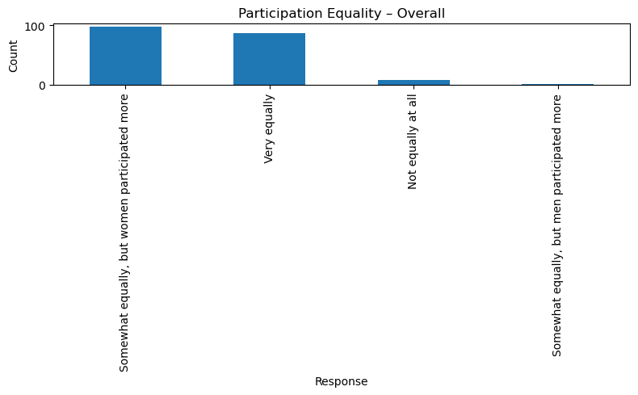

B24. How have the new practices affected decision-making on what to grow or how to use farm income in your household?
(Percentages)
Category | Much more input from women | A little more input from women | No change | Less input from women
Gender
Female | 95.8 | 2.1 | 2.1 | 0.0
Male | 84.6 | 5.8 | 7.7 | 1.9
County
Bungoma County | 93.8 | 3.1 | 2.3 | 0.8
Trans Nzoia County | 90.8 | 3.1 | 6.2 | 0.0
Sublocation
Bumula | 89.2 | 6.2 | 3.1 | 1.5
Mt Elgon | 98.5 | 0.0 | 1.5 | 0.0
Trans-Nzoia West | 90.8 | 3.1 | 6.2 | 0.0
Beneficiary Status
Beneficiary | 96.9 | 0.8 | 1.6 | 0.8
Non-beneficiary | 84.8 | 7.6 | 7.6 | 0.0
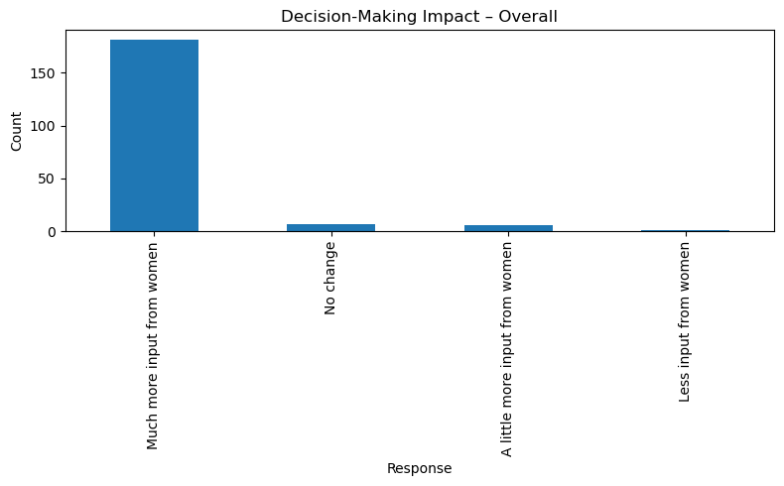

B25. How well do you think the project considered the needs of youth, women, and the very poor?
(Percentages)
Category | Very Well | Somewhat Well | Not Very Well | Don't Know
Gender
Female | 76.9 | 17.5 | 3.5 | 2.1
Male | 80.8 | 11.5 | 5.8 | 1.9
County
Bungoma County | 78.5 | 15.4 | 4.6 | 1.5
Trans Nzoia County | 76.9 | 16.9 | 3.1 | 3.1
Sublocation
Bumula | 81.5 | 12.3 | 4.6 | 1.5
Mt Elgon | 75.4 | 18.5 | 4.6 | 1.5
Trans-Nzoia West | 76.9 | 16.9 | 3.1 | 3.1
Beneficiary Status
Beneficiary | 79.8 | 19.4 | 0.8 | 0.0
Non-beneficiary | 74.2 | 9.1 | 10.6 | 6.1

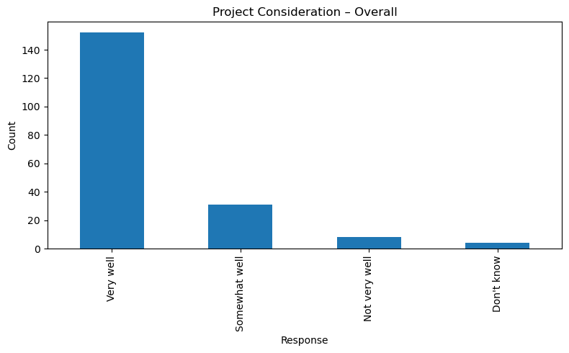

Identify Enabling/Constraining Factors(B20-B22)
B20. What made it easy for you to adopt these new methods?
B21. What were the biggest challenges or barriers?
B22. Did you receive support from others outside the project to use these practices?

B20. What made it easy for you to adopt these new methods?
*(Top 5 Enablers by Category - Percentages)*
Category | High-Quality, Practical Training | Support & Sharing Within Farmer Group | Seeing Good Results Quickly | Learning from Demonstration Farms | Support from Project Staff
Overall Top Enablers | 24.5 | 14.0 | 11.9 | 11.2 | 7.0
Gender
Female | 20.3 | 14.0 | 11.9 | 11.2 | 7.0
Male | 32.7 | 17.3 | 18.8 | 13.5 | 9.6
County
Bungoma County | 21.5 | 16.9 | 7.7 | 13.1 | 5.4
Trans Nzoia County | 27.7 | 10.8 | 10.8 | 7.7 | 10.8
Beneficiary Status
Beneficiary | 28.7 | 21.7 | 10.9 | 10.1 | 4.7
Non-beneficiary | 13.6 | 1.5 | 4.5 | 13.6 | 13.6

Enablers and Barriers (B20/B21 Cross-tab Summary)

Top Enablers | % of Respondents
Training by DESECE | 82%
Peer/Group Learning | 64%
Availability of Local Materials | 57%
Top Barriers | % of Respondents
Cost of Inputs (drip, pipes) | 48%
Water Access Challenges | 36%
Labor Availability | 29%

B21. What were the biggest challenges or barriers?
Category | High Cost of Inputs/Materials | Climate Conditions (Drought/Floods) | Pests/Diseases | Requires More Labour/Time | Lack of Access to Water
Overall Top Challenges | 13.8 | 6.3 | 5.6 | 8.4 | 4.9
Gender
Female | 14.0 | 5.6 | 4.9 | 8.4 | 4.9
Male | 13.5 | 7.7 | 15.4 | 3.8 | 5.8
County
Bungoma County | 10.8 | 4.6 | 10.0 | 6.9 | 3.1
Trans Nzoia County | 20.0 | 9.2 | 4.6 | 7.7 | 4.6
Beneficiary Status
Beneficiary | 15.5 | 5.4 | 10.9 | 9.3 | 3.1
Non-beneficiary | 10.6 | 7.6 | 3.0 | 3.0 | 4.5

B21: Biggest Challenges or Barriers to Adoption
Barrier | Frequency
Cost | 111
Knowledge/Skills Gap | 46
Climate-Related Challenges | 68
Pests | 70
Water Scarcity | 37
Conflict | 3
Additional Labour Required | 44

B22. Did you receive support from others outside the project to use these practices?
Category | Yes, from other farmers | No, only from the project | No support at all | Yes, from local agro-dealers | Yes, from local government officers
Gender
Female | 47.6 | 44.8 | 5.6 | 0.7 | 1.4
Male | 59.6 | 30.8 | 1.9 | 3.8 | 3.8
County
Bungoma County | 50.0 | 40.8 | 4.6 | 2.3 | 2.3
Trans Nzoia County | 52.3 | 41.5 | 4.6 | 0.0 | 1.5
Sublocation
Bumula | 55.4 | 36.9 | 1.5 | 1.5 | 4.6
Mt Elgon | 44.6 | 44.6 | 7.7 | 3.1 | 0.0
Trans-Nzoia West | 52.3 | 41.5 | 4.6 | 0.0 | 1.5
Beneficiary Status
Beneficiary | 72.1 | 20.9 | 3.9 | 0.8 | 2.3
Non-beneficiary | 9.1 | 80.3 | 6.1 | 3.0 | 1.5

Compare Adoption by Sub-Group
B1. Which of the following climate-resilient farming methods have you heard about? And which have you adopted or used on your farm in the last 12 months?
B3a. Do you currently use this practice on your farm?
A4. Gender
A5. Age
A6. Respondent Category

B1) Climate Resilient Farming Methods
Practice | No. of resp | No. adopted | Adoption % | Target (%) | Gap to Target (%)
Agroforestry | 194 | 189 | 96.92 | 80 | -16.92
Drought-tolerant Varieties | 195 | 173 | 88.72 | 80 | -8.72
Crop Rotation | 195 | 193 | 98.97 | 80 | -18.97
Mulching | 192 | 173 | 88.72 | 80 | -8.72
Composting | 195 | 192 | 98.46 | 80 | -18.46
Water Harvesting | 195 | 194 | 99.49 | 80 | -19.49
Drip Irrigation | 194 | 149 | 76.41 | 80 | +3.59 (below target)
Kitchen Gardens | 195 | 193 | 98.97 | 80 | -18.97
Food Forests | 195 | 187 | 95.90 | 80 | -15.90
Soil Conservation | 195 | 180 | 92.31 | 80 | -12.31

1. Adoption by Gender (Summary Table)
Practice | Female Adoption % | Male Adoption %
Agroforestry | 96.05 | 98.08
Composting | 99.30 | 100.00
Water Harvesting | 98.60 | 100.00
Drip Irrigation | 78.17 | 73.08

Detailed Tables for Each Practice

AGROFORESTRY
agroforestry_heard_by_gender
gender | count_No | count_Yes | count_nan | percentage_No | percentage_Yes | percentage_nan
Female | 1 | 141 | 1 | 0.70 | 98.60 | 0.70
Male | 1 | 51 | 0 | 1.92 | 98.08 | 0
agroforestry_heard_by_age_group
age_group | count_No | count_Yes | count_nan | percentage_No | percentage_Yes | percentage_nan
18-25 | 0 | 1 | 0 | 0 | 100 | 0
26-35 | 0 | 18 | 0 | 0 | 100 | 0
36-45 | 0 | 29 | 0 | 0 | 100 | 0
46-55 | 0 | 62 | 0 | 0 | 100 | 0
56+ | 2 | 82 | 1 | 2.35 | 96.47 | 1.18
agroforestry_heard_by_county
county_name | count_No | count_Yes | count_nan | percentage_No | percentage_Yes | percentage_nan
Bungoma County | 0 | 129 | 1 | 0 | 99.23 | 0.77
Trans Nzoia County | 2 | 63 | 0 | 3.08 | 96.92 | 0
agroforestry_heard_by_primary_livelihood
primary_livelihood | count_No | count_Yes | count_nan | percentage_No | percentage_Yes | percentage_nan
Crop & Livestock | 0 | 88 | 1 | 0 | 98.88 | 1.12
Crop farming | 2 | 102 | 0 | 1.92 | 98.08 | 0
Livestock rearing | 0 | 1 | 0 | 0 | 100 | 0
Other (specify) | 0 | 1 | 0 | 0 | 100 | 0
agroforestry_heard_by_sublocation
sublocation_bungoma_trans_nzoia | count_No | count_Yes | count_nan | percentage_No | percentage_Yes | percentage_nan
Bumula | 0 | 65 | 0 | 0 | 100 | 0
Mt Elgon | 0 | 64 | 1 | 0 | 98.46 | 1.54
Trans-Nzoia West | 2 | 63 | 0 | 3.08 | 96.92 | 0
agroforestry_adopted_by_gender
gender | count_No | count_Yes | count_nan | percentage_No | percentage_Yes | percentage_nan
Female | 4 | 138 | 1 | 2.80 | 96.50 | 0.70
Male | 1 | 51 | 0 | 1.92 | 98.08 | 0
agroforestry_adopted_by_age_group
age_group | count_No | count_Yes | count_nan | percentage_No | percentage_Yes | percentage_nan
18-25 | 0 | 1 | 0 | 0 | 100 | 0
26-35 | 0 | 18 | 0 | 0 | 100 | 0
36-45 | 0 | 29 | 0 | 0 | 100 | 0
46-55 | 1 | 61 | 0 | 1.61 | 98.39 | 0
56+ | 4 | 80 | 1 | 4.71 | 94.12 | 1.18
agroforestry_adopted_by_county
county_name | count_No | count_Yes | count_nan | percentage_No | percentage_Yes | percentage_nan
Bungoma County | 2 | 127 | 1 | 1.54 | 97.69 | 0.77
Trans Nzoia County | 3 | 62 | 0 | 4.62 | 95.38 | 0
agroforestry_adopted_by_primary_livelihood
primary_livelihood | count_No | count_Yes | count_nan | percentage_No | percentage_Yes | percentage_nan
Crop & Livestock | 2 | 86 | 1 | 2.25 | 96.63 | 1.12
Crop farming | 3 | 101 | 0 | 2.88 | 97.12 | 0
Livestock rearing | 0 | 1 | 0 | 0 | 100 | 0
Other (specify) | 0 | 1 | 0 | 0 | 100 | 0
agroforestry_adopted_by_sublocation
sublocation_bungoma_trans_nzoia | count_No | count_Yes | count_nan | percentage_No | percentage_Yes | percentage_nan
Bumula | 0 | 65 | 0 | 0 | 100 | 0
Mt Elgon | 2 | 62 | 1 | 3.08 | 95.38 | 1.54
Trans-Nzoia West | 3 | 62 | 0 | 4.62 | 95.38 | 0

COMPOSTING
composting_heard_by_gender
gender | count_No | count_Yes | percentage_No | percentage_Yes
Female | 1 | 142 | 0.70 | 99.30
Male | 0 | 52 | 0 | 100
composting_heard_by_age_group
age_group | count_No | count_Yes | percentage_No | percentage_Yes
18-25 | 0 | 1 | 0 | 100
26-35 | 0 | 18 | 0 | 100
36-45 | 0 | 29 | 0 | 100
46-55 | 0 | 62 | 0 | 100
56+ | 1 | 84 | 1.18 | 98.82
composting_heard_by_county
county_name | count_No | count_Yes | percentage_No | percentage_Yes
Bungoma County | 0 | 130 | 0 | 100
Trans Nzoia County | 1 | 64 | 1.54 | 98.46
composting_heard_by_primary_livelihood
primary_livelihood | count_No | count_Yes | percentage_No | percentage_Yes
Crop & Livestock | 1 | 88 | 1.12 | 98.88
Crop farming | 0 | 104 | 0 | 100
Other | 0 | 1 | 0 | 100

composting_heard_by_sublocation
sublocation_bungoma_trans_nzoia | count_No | count_Yes | percentage_No | percentage_Yes
Bumula | 0 | 65 | 0 | 100
Mt Elgon | 0 | 65 | 0 | 100
Trans-Nzoia West | 1 | 64 | 1.54 | 98.46
composting_adopted_by_gender
gender | count_No | count_Yes | percentage_No | percentage_Yes
Female | 3 | 140 | 2.10 | 97.90
Male | 0 | 52 | 0 | 100
composting_adopted_by_age_group
age_group | count_No | count_Yes | percentage_No | percentage_Yes
18-25 | 0 | 1 | 0 | 100
26-35 | 0 | 18 | 0 | 100
36-45 | 0 | 29 | 0 | 100
46-55 | 1 | 61 | 1.61 | 98.39
56+ | 2 | 83 | 2.35 | 97.65

composting_adopted_by_county
county_name | count_No | count_Yes | percentage_No | percentage_Yes
Bungoma County | 1 | 129 | 0.77 | 99.23
Trans Nzoia County | 2 | 63 | 3.08 | 96.92
composting_adopted_by_primary_livelihood
primary_livelihood | count_No | count_Yes | percentage_No | percentage_Yes
Crop & Livestock | 2 | 87 | 2.25 | 97.75
Crop farming | 1 | 103 | 0.96 | 99.04
Other | 0 | 1 | 0 | 100
composting_adopted_by_sublocation
sublocation_bungoma_trans_nzoia | count_No | count_Yes | percentage_No | percentage_Yes
Bumula | 0 | 65 | 0 | 100
Mt Elgon | 1 | 64 | 1.54 | 98.46
Trans-Nzoia West | 2 | 63 | 3.08 | 96.92
- WATER HARVESTING
water_harvesting_heard_by_gender
gender | count_No | count_Yes | count_nan | percentage_No | percentage_Yes | percentage_nan
Female | 1 | 141 | 1 | 0.70 | 98.60 | 0.70
Male | 0 | 52 | 0 | 0 | 100 | 0

water_harvesting_heard_by_age_group
age_group | count_No | count_Yes | count_nan | percentage_No | percentage_Yes | percentage_nan
18-25 | 0 | 1 | 0 | 0 | 100 | 0
26-35 | 0 | 18 | 0 | 0 | 100 | 0
36-45 | 0 | 29 | 0 | 0 | 100 | 0
46-55 | 0 | 62 | 0 | 0 | 100 | 0
56+ | 1 | 83 | 1 | 1.18 | 97.65 | 1.18
water_harvesting_heard_by_county
county_name | count_No | count_Yes | count_nan | percentage_No | percentage_Yes | percentage_nan
Bungoma County | 0 | 129 | 1 | 0 | 99.23 | 0.77
Trans Nzoia County | 1 | 64 | 0 | 1.54 | 98.46 | 0
water_harvesting_heard_by_primary_livelihood
primary_livelihood | count_No | count_Yes | count_nan | percentage_No | percentage_Yes | percentage_nan
Crop & Livestock | 1 | 87 | 1 | 1.12 | 97.75 | 1.12
Crop farming | 0 | 104 | 0 | 0 | 100 | 0
Other | 0 | 1 | 0 | 0 | 100 | 0
water_harvesting_heard_by_sublocation
sublocation_bungoma_trans_nzoia | count_No | count_Yes | count_nan | percentage_No | percentage_Yes | percentage_nan
Bumula | 0 | 65 | 0 | 0 | 100 | 0
Mt Elgon | 0 | 64 | 1 | 0 | 98.46 | 1.54
Trans-Nzoia West | 1 | 64 | 0 | 1.54 | 98.46 | 0
water_harvesting_adopted_by_gender
gender | count_No | count_Yes | count_nan | percentage_No | percentage_Yes | percentage_nan
Female | 1 | 142 | 0 | 0.70 | 99.30 | 0
Male | 0 | 52 | 0 | 0 | 100 | 0
water_harvesting_adopted_by_age_group
age_group | count_No | count_Yes | count_nan | percentage_No | percentage_Yes | percentage_nan
18-25 | 0 | 1 | 0 | 0 | 100 | 0
26-35 | 0 | 18 | 0 | 0 | 100 | 0
36-45 | 0 | 29 | 0 | 0 | 100 | 0
46-55 | 0 | 62 | 0 | 0 | 100 | 0
56+ | 1 | 84 | 0 | 1.18 | 98.82 | 0
water_harvesting_adopted_by_county
county_name | count_No | count_Yes | count_nan | percentage_No | percentage_Yes | percentage_nan
Bungoma County | 0 | 130 | 0 | 0 | 100 | 0
Trans Nzoia County | 1 | 64 | 0 | 1.54 | 98.46 | 0
water_harvesting_adopted_by_primary_livelihood
primary_livelihood | count_No | count_Yes | count_nan | percentage_No | percentage_Yes | percentage_nan
Crop & Livestock | 1 | 88 | 0 | 1.12 | 98.88 | 0
Crop farming | 0 | 104 | 0 | 0 | 100 | 0
Other | 0 | 1 | 0 | 0 | 100 | 0

water_harvesting_adopted_by_sublocation
sublocation_bungoma_trans_nzoia | count_No | count_Yes | count_nan | percentage_No | percentage_Yes | percentage_nan
Bumula | 0 | 65 | 0 | 0 | 100 | 0
Mt Elgon | 0 | 65 | 0 | 0 | 100 | 0
Trans-Nzoia West | 1 | 64 | 0 | 1.54 | 98.46 | 0

DRIP IRRIGATION
drip_irrigation_heard_by_gender
gender | count_No | count_Yes | percentage_No | percentage_Yes
Female | 24 | 119 | 16.78 | 83.22
Male | 10 | 42 | 19.23 | 80.77
drip_irrigation_heard_by_age_group
age_group | count_No | count_Yes | percentage_No | percentage_Yes
18-25 | 0 | 1 | 0 | 100
26-35 | 2 | 16 | 11.11 | 88.89
36-45 | 3 | 26 | 10.34 | 89.66
46-55 | 8 | 54 | 12.90 | 87.10
56+ | 21 | 64 | 24.71 | 75.29
drip_irrigation_heard_by_county
county_name | count_No | count_Yes | percentage_No | percentage_Yes
Bungoma County | 21 | 109 | 16.15 | 83.85
Trans Nzoia County | 13 | 52 | 20.00 | 80.00
drip_irrigation_heard_by_primary_livelihood
primary_livelihood |  | count_No | count_Yes | percentage_No | percentage_Yes
Crop & Livestock | 24 |  | 65 | 26.97 | 73.03
Crop farming | 10 |  | 94 | 9.62 | 90.38
Other | 0 |  | 1 | 0 | 100
drip_irrigation_heard_by_sublocation
sublocation_bungoma_trans_nzoia | count_No | count_Yes | percentage_No | percentage_Yes
Bumula | 13 | 52 | 20.00 | 80.00
Mt Elgon | 8 | 57 | 12.31 | 87.69
Trans-Nzoia West | 13 | 52 | 20.00 | 80.00
drip_irrigation_adopted_by_gender
gender | count_No | count_Yes | percentage_No | percentage_Yes
Female | 31 | 111 | 21.82 | 78.17
Male | 14 | 38 | 26.92 | 73.08
drip_irrigation_adopted_by_age_group
age_group | count_No | count_Yes | percentage_No | percentage_Yes
18-25 | 0 | 1 | 0 | 100
26-35 | 3 | 15 | 16.67 | 83.33
36-45 | 4 | 25 | 13.79 | 86.21
46-55 | 10 | 52 | 16.13 | 83.87
56+ | 28 | 56 | 33.33 | 66.67
drip_irrigation_adopted_by_county
county_name | count_No | count_Yes | percentage_No | percentage_Yes
Bungoma County | 25 | 105 | 19.23 | 80.77
Trans Nzoia County | 20 | 44 | 31.25 | 68.75
drip_irrigation_adopted_by_primary_livelihood
primary_livelihood | count_No | count_Yes | percentage_No | percentage_Yes
Crop & Livestock | 33 | 56 | 37.08 | 62.92
Crop farming | 12 | 92 | 11.54 | 88.46
Other | 0 | 1 | 0 | 100
drip_irrigation_adopted_by_sublocation
sublocation_bungoma_trans_nzoia | count_No | count_Yes | percentage_No | percentage_Yes
Bumula | 13 | 52 | 20.00 | 80.00
Mt Elgon | 19 | 46 | 29.23 | 70.77
Trans-Nzoia West | 13 | 51 | 20.31 | 79.69

2. Adoption by Age Group (Summary Table)
agroforestry_adopted_by_age_group
age_group | count_No | count_Yes | count_nan | percentage_No | percentage_Yes | percentage_nan
18-25 | 0 | 1 | 0 | 0 | 100 | 0
26-35 | 0 | 18 | 0 | 0 | 100 | 0
36-45 | 0 | 29 | 0 | 0 | 100 | 0
46-55 | 1 | 61 | 0 | 1.61 | 98.39 | 0
56+ | 4 | 80 | 1 | 4.71 | 94.12 | 1.18
composting_adopted_by_age_group
age_group | count_No | count_Yes | percentage_No | percentage_Yes
18-25 | 0 | 1 | 0 | 100
26-35 | 0 | 18 | 0 | 100
36-45 | 0 | 29 | 0 | 100
46-55 | 1 | 61 | 1.61 | 98.39
56+ | 2 | 83 | 2.35 | 97.65
water_harvesting_adopted_by_age_group
age_group | count_No | count_Yes | count_nan | percentage_No | percentage_Yes | percentage_nan
18-25 | 0 | 1 | 0 | 0 | 100 | 0
26-35 | 0 | 18 | 0 | 0 | 100 | 0
36-45 | 0 | 29 | 0 | 0 | 100 | 0
46-55 | 0 | 62 | 0 | 0 | 100 | 0
56+ | 1 | 84 | 0 | 1.18 | 98.82 | 0
drip_irrigation_adopted_by_age_group
age_group | count_No | count_Yes | percentage_No | percentage_Yes
18-25 | 0 | 1 | 0 | 100
26-35 | 3 | 15 | 16.67 | 83.33
36-45 | 4 | 25 | 13.79 | 86.21
46-55 | 10 | 52 | 16.13 | 83.87
56+ | 28 | 56 | 33.33 | 66.67

- Adoption Score Distribution Histogram
Shows most farmers adopted 7–10 practices, clustering at the upper end.
→ Indicates high intensity adoption, not just selective uptake.
- Top 5 Practices Bar Chart

B3a) Current Use of Climate-Resilient Farming Practices
B3a. Do you currently use this practice on your farm?

B3a: Current Use of Climate-Resilient Farming Practices
Practice (B3a) | Number of Farmers Using | Average Quantity/Acres
Compost use (bags) | 191 | 11.41
Manure use (bags) | 184 | 10.51
Cover crops (acres) | 189 | 0.63
Zero tillage (acres) | 121 | 0.58
Crop rotation (acres) | 189 | 0.67

1. Compost Use (Average Bags per Season)
compost_use_by_gender
Gender | Average Bags/Season | Median Bags/Season | Standard Deviation
Female | 10.0 | 7.0 | 15.4
Male | 15.1 | 9.0 | 9.3
compost_use_by_age_group
Age Group | Average Bags/Season | Median Bags/Season
18-25 | 8.0 | 8.0
26-35 | 9.5 | 7.0
36-45 | 10.2 | 7.0
46-55 | 10.8 | 7.5
56+ | 11.8 | 6.0
compost_use_by_county
County | Average Bags/Season | Median Bags/Season
Bungoma County | 12.9 | 10.0
Trans Nzoia County | 8.4 | 5.0
compost_use_by_primary_livelihood
Primary Livelihood | Average Bags/Season
Crop & Livestock | 14.9
Crop Farming | 8.5

2. Manure Use (Average Bags per Season)
manure_use_by_gender
Gender | Average Bags/Season | Median Bags/Season | Standard Deviation
Female | 10.5 | 6.0 | 15.4
Male | 10.5 | 6.0 | 9.3
manure_use_by_county
County | Average Bags/Season
Bungoma County | 11.5
Trans Nzoia County | 8.4
manure_use_by_primary_livelihood
Primary Livelihood | Average Bags/Season
Crop & Livestock | 12.8
Crop Farming | 8.5

3. Cover Crops (Average Acres)
cover_crops_by_gender
Gender | Average Acres
Female | 0.63
Male | 0.63
cover_crops_by_age_group
Age Group | Average Acres
18-25 | 0.50
26-35 | 0.53
36-45 | 0.60
46-55 | 0.65
56+ | 0.68
cover_crops_by_primary_livelihood
Primary Livelihood | Average Acres
Crop & Livestock | 0.55
Crop Farming | 0.69

4. Zero Tillage (Average Acres)
zero_tillage_by_gender
Gender | Average Acres
Female | 0.58
Male | 0.58

5. Crop Rotation (Average Acres)
crop_rotation_by_gender
Gender | Average Acres
Female | 0.67
Male | 0.67
crop_rotation_by_age_group
Age Group | Average Acres
18-25 | 0.50
26-35 | 0.65
36-45 | 0.70
46-55 | 0.68
56+ | 0.67
crop_rotation_by_primary_livelihood
Primary Livelihood | Average Acres
Crop & Livestock | 0.62
Crop Farming | 0.71

Gender Differences
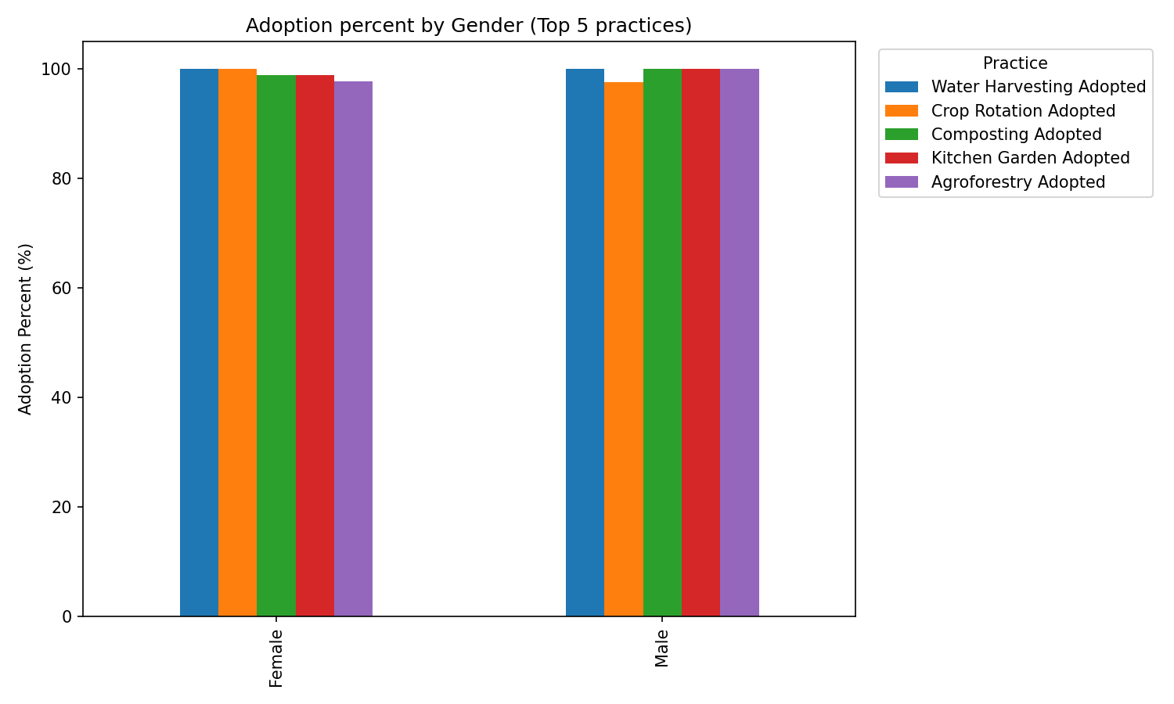

Cookstove Use & Barriers (F2e–F2g)
F2e. Is the improved cook stove currently being used in your household?
F2f. How often do you use the improved cook stove?
F2g. What are the main reasons for not using the improved cook stove more regularly?

F2e. Is the improved cook stove currently being used in your household?
Category | Yes | No
Overall | 84.6% | 15.4%
Gender
Female | 82.5% | 17.5%
Male | 90.4% | 9.6%
County
Bungoma County | 83.1% | 16.9%
Trans Nzoia County | 86.2% | 13.8%
Sublocation
Bumula | 86.2% | 13.8%
Mt Elgon | 80.0% | 20.0%
Trans-Nzoia West | 86.2% | 13.8%
Age Group
18-25 | 100.0% | 0.0%
26-35 | 76.9% | 23.1%
36-45 | 85.7% | 14.3%
46-55 | 87.0% | 13.0%
56+ | 83.3% | 16.7%
Beneficiary Status | Stove Received | Stove Not Received
Project Beneficiaries | 99 (76.2%) | 31 (23.8%)

F2f. How often do you use the improved cook stove?
(Percentages based on those who use the stove)
Category | Always (for all main meals) | Often (most meals) | Sometimes (few meals per week) | Rarely (less than once per week)
Overall | 83.2% | 13.6% | 0.8% | 0.8%
Gender
Female | 75.6% | 20.7% | 1.7% | 1.7%
Male | 76.6% | 19.1% | 0.0% | 4.3%
County
Bungoma County | 75.9% | 20.4% | 1.9% | 1.9%
Trans Nzoia County | 75.4% | 21.1% | 0.0% | 3.5%
Sublocation
Bumula | 78.6% | 17.9% | 1.8% | 1.8%
Mt Elgon | 73.1% | 23.1% | 1.9% | 1.9%
Trans-Nzoia West | 75.4% | 21.1% | 0.0% | 3.5%
Age Group
18-25 | 100.0% | 0.0% | 0.0% | 0.0%
26-35 | 72.7% | 27.3% | 0.0% | 0.0%
36-45 | 78.6% | 21.4% | 0.0% | 0.0%
46-55 | 75.0% | 21.4% | 1.8% | 1.8%
56+ | 75.0% | 18.8% | 2.1% | 4.2%
Beneficiary Status | Stove Received | Stove Not Received
Project Beneficiaries | 83 (90.2% of recipients) | 9 (9.8% of recipients)

F2g. What are the main reasons for not using the improved cook stove more regularly?
(Based on respondents who do not use the stove regularly)
Reason for Non-Regular Use | Frequency |  | Percent of Non-Regular Users |  | Demographics
Stove is broken/needs repair | 2 |  | 1.6% |  | Female, 56+, Bumula
Preference for traditional stove (taste, speed, etc.) | 2 |  | 1.6% |  | Female, 56+, Bumula
Barrier |  | Frequency |  | Percent (%)
Stove broken |  | 2 |  | 1.6
Fuel challenges |  | 2 |  | 1.6
Stove preference |  | 2 |  | 1.6
Stove too small |  | 2 |  | 1.6
Other barriers |  | 2 |  | 1.6
Missing / NA |  | 128 |  | 98.5

Phase 3: Analytical Framework by Evaluation Question

EQ3: Relevance – Alignment with Needs

C1. Before this project, what was your single biggest problem in farming?
C2. How well did the project's activities address this specific problem?
B1. Which of the following climate-resilient farming methods have you heard about? And which have you adopted or used on your farm in the last 12 months?
B3a. Do you currently use this practice on your farm?
C3. Was the training provided relevant to your actual farming conditions?
B7. Have you noticed more farmers in this village using these new practices compared to two years ago?
C4. Have you shared knowledge or skills from this project with other farmers?
C5. Have you seen neighbours copying any project practices?

Link Problems to Solutions, Assess Perceived Relevance, Measure Peer-to-Peer Learning

C1. Before this project, what was your single biggest problem in farming?
c1_c2_problem_solution_linkage
Biggest Problem | Not Addressed | Not Very Well | Somewhat Well | Very Well
Lack of income | 0% | 4% | 0% | 96%
Low crop yields | 0% | 0% | 15% | 85%
Poor soil fertility | 0% | 0% | 22% | 78%
Unreliable rainfall/Drought | 0% | 2% | 7% | 91%
Pests/Diseases | 0% | 0% | 25% | 75%
Other | 11% | 0% | 0% | 89%
c2_problem_addressed_by_gender
Gender | Not Addressed | Not Very Well | Somewhat Well | Very Well
Female | 0.7% | 1.4% | 11.9% | 86.0%
Male | 0.0% | 0.0% | 17.3% | 82.7%
c2_problem_addressed_by_county
County | Not Addressed | Not Very Well | Somewhat Well | Very Well
Bungoma County | 0.0% | 0.8% | 10.8% | 88.5%
Trans Nzoia County | 1.5% | 1.5% | 18.5% | 78.5%
c2_problem_addressed_by_sublocation
Sublocation | Not Addressed | Not Very Well | Somewhat Well | Very Well
Bumula | 0.0% | 1.5% | 12.3% | 86.2%
Mt Elgon | 0.0% | 0.0% | 9.2% | 90.8%
Trans-Nzoia West | 1.5% | 1.5% | 18.5% | 78.5%
C3. Was the training provided relevant to your actual farming conditions?

C3: Training Relevance Assessment
c3_training_relevance_overall
Relevance Level | Count | Percentage
Very relevant | 165 | 84.6%
Somewhat relevant | 29 | 14.9%
Not relevant at all | 1 | 0.5%
c3_training_relevance_by_gender
Gender | Not Relevant | Somewhat Relevant | Very Relevant
Female | 0.7% | 13.3% | 86.0%
Male | 0.0% | 19.2% | 80.8%
c3_training_relevance_by_county
County | Not Relevant | Somewhat Relevant | Very Relevant
Bungoma County | 0.0% | 13.9% | 86.2%
Trans Nzoia County | 1.5% | 16.9% | 81.5%
c3_training_relevance_by_sublocation
Sublocation | Not Relevant | Somewhat Relevant | Very Relevant
Bumula | 0.0% | 13.9% | 86.2%
Mt Elgon | 0.0% | 13.9% | 86.2%
Trans-Nzoia West | 1.5% | 16.9% | 81.5%
B1. Which of the following climate-resilient farming methods have you heard about? And which have you adopted or used on your farm in the last 12 months?

B1: Climate-Smart Practice Adoption Rates(Already Dissagragated on the Effectiveness Criteria)
b1_practice_adoption_rates
Practice | Heard | Adopted | Adoption Rate
Water Harvesting | 193 | 194 | 99.5%
Kitchen Garden | 194 | 193 | 99.0%
Crop Rotation | 194 | 193 | 99.0%
Composting | 194 | 192 | 98.5%
Food Forest | 192 | 187 | 95.9%
Agroforestry | 192 | 189 | 95.9%
Soil Conservation | 183 | 180 | 92.3%
Drought Varieties | 186 | 173 | 88.7%
Mulching | 186 | 173 | 88.7%
Drip Irrigation | 161 | 149 | 76.4%
B3a. Do you currently use this practice on your farm?

B3a: Current Use of Climate-Resilient Farming Practices
Practice (B3a) | Number of Farmers Using | Average Quantity/Acres
Compost use (bags) | 191 | 11.41
Manure use (bags) | 184 | 10.51
Cover crops (acres) | 189 | 0.63
Zero tillage (acres) | 121 | 0.58
Crop rotation (acres) | 189 | 0.67

1. Compost Use (Average Bags per Season)
compost_use_by_gender
Gender | Average Bags/Season | Median Bags/Season | Standard Deviation
Female | 10.0 | 7.0 | 15.4
Male | 15.1 | 9.0 | 9.3
compost_use_by_age_group
Age Group | Average Bags/Season | Median Bags/Season
18-25 | 8.0 | 8.0
26-35 | 9.5 | 7.0
36-45 | 10.2 | 7.0
46-55 | 10.8 | 7.5
56+ | 11.8 | 6.0
compost_use_by_county
County | Average Bags/Season | Median Bags/Season
Bungoma County | 12.9 | 10.0
Trans Nzoia County | 8.4 | 5.0
compost_use_by_primary_livelihood
Primary Livelihood | Average Bags/Season
Crop & Livestock | 14.9
Crop Farming | 8.5

2. Manure Use (Average Bags per Season)
manure_use_by_gender
Gender | Average Bags/Season | Median Bags/Season | Standard Deviation
Female | 10.5 | 6.0 | 15.4
Male | 10.5 | 6.0 | 9.3
manure_use_by_county
County | Average Bags/Season
Bungoma County | 11.5
Trans Nzoia County | 8.4
manure_use_by_primary_livelihood
Primary Livelihood | Average Bags/Season
Crop & Livestock | 12.8
Crop Farming | 8.5

3. Cover Crops (Average Acres)
cover_crops_by_gender
Gender | Average Acres
Female | 0.63
Male | 0.63
cover_crops_by_age_group
Age Group | Average Acres
18-25 | 0.50
26-35 | 0.53
36-45 | 0.60
46-55 | 0.65
56+ | 0.68
cover_crops_by_primary_livelihood
Primary Livelihood | Average Acres
Crop & Livestock | 0.55
Crop Farming | 0.69

4. Zero Tillage (Average Acres)
zero_tillage_by_gender
Gender | Average Acres
Female | 0.58
Male | 0.58
5. Crop Rotation (Average Acres)
crop_rotation_by_gender
Gender | Average Acres
Female | 0.67
Male | 0.67
crop_rotation_by_age_group
Age Group | Average Acres
18-25 | 0.50
26-35 | 0.65
36-45 | 0.70
46-55 | 0.68
56+ | 0.67
crop_rotation_by_primary_livelihood
Primary Livelihood | Average Acres
Crop & Livestock | 0.62
Crop Farming | 0.71
B7. Have you noticed more farmers in this village using these new practices compared to two years ago?

B7: Community-Level Adoption Spread
b7_community_adoption_by_gender
Gender | Don't Know | Fewer | No Change | Few More | Many More
Female | 3.5% | 3.5% | 2.8% | 14.7% | 75.5%
Male | 0.0% | 0.0% | 1.9% | 5.8% | 92.3%
b7_community_adoption_by_sublocation
Sublocation | Don't Know | Fewer | No Change | Few More | Many More
Bumula | 1.5% | 0.0% | 1.5% | 6.2% | 90.8%
Mt Elgon | 3.1% | 3.1% | 3.1% | 20.0% | 70.8%
Trans-Nzoia West | 3.1% | 4.6% | 3.1% | 10.8% | 78.5%
C4. Have you shared knowledge or skills from this project with other farmers?
C5. Have you seen neighbours copying any project practices?

C4 → C5: Peer-to-Peer Learning & Adoption
c4_c5_knowledge_sharing_vs_adoption
Knowledge Shared | No Adoption | Few Copying | Many Copying
No sharing | 55% | 27% | 18%
Shared with few (1-4) | 7% | 43% | 50%
Shared with many (5+) | 5% | 7% | 88%
c4_knowledge_sharing_by_gender
Gender | No Sharing | Shared with Few | Shared with Many
Female | 7.0% | 16.1% | 76.9%
Male | 1.9% | 13.5% | 84.6%
c4_knowledge_sharing_by_county
County | No Sharing | Shared with Few | Shared with Many
Bungoma County | 4.6% | 15.4% | 80.0%
Trans Nzoia County | 7.7% | 15.4% | 76.9%

c5_neighbor_adoption_by_gender
Gender | No Adoption | Few Copying | Many Copying
Female | 8.4% | 14.7% | 76.9%
Male | 5.8% | 11.5% | 82.7%
c5_neighbor_adoption_by_sublocation
Sublocation | No Adoption | Few Copying | Many Copying
Bumula | 1.5% | 12.3% | 86.2%
Mt Elgon | 15.4% | 15.4% | 69.2%
Trans-Nzoia West | 6.2% | 13.9% | 80.0%

Phase 3: Analytical Framework by Evaluation Question

EQ3: EFFICIENCY – ASSES ECCRAS RESOURCES USAGE
Goal: the goal is to assess whether ECCRAS used its resources (time, training, demonstrations, inputs) in a way that resulted in efficient uptake and use of practices by farmers.
Practice | Gender (F/M) | Age (High/Low) | County (Bungoma/Trans Nzoia) | Sublocation (High/Low) | Beneficiary Status
Agroforestry | 96.5% / 98.1% | 56+ (94.1%) / 46-55 (98.4%) | 97.7% / 95.4% | Bumula (100%) / Mt Elgon & T-N West (95.4%) | 96.9%
Drought-Tolerant Varieties | 88.8% / 88.5% | 36-45 (96.6%) / 56+ (84.7%) | 90.8% / 84.6% | Bumula & Mt Elgon (90.8%) / T-N West (84.6%) | 88.7%
Crop Rotation | 99.3% / 98.1% | 56+ (98.8%) / 46-55 (98.4%) | 99.2% / 98.5% | Bumula (100%) / Mt Elgon & T-N West (98.5%) | 99.0%
Mulching | 86.0% / 96.2% | 36-45 (96.6%) / 56+ (82.4%) | 90.0% / 86.2% | Bumula (92.3%) / T-N West (86.2%) | 88.7%
Composting | 97.9% / 100% | 36-45 & 46-55 (100%) / 56+ (97.6%) | 99.2% / 96.9% | Bumula (100%) / T-N West (96.9%) | 98.5%
Water Harvesting | 99.3% / 100% | 18-25 & 36-45 & 46-55 (100%) / 56+ (98.8%) | 100% / 98.5% | Bumula & Mt Elgon (100%) / T-N West (98.5%) | 99.5%
Drip Irrigation | 77.6% / 73.1% | 36-45 (82.8%) / 56+ (71.8%) | 75.4% / 78.5% | Bumula (80.0%) / Mt Elgon (70.8%) | 76.4%
Kitchen Gardens | 98.6% / 100% | 36-45 & 56+ (100%) / 46-55 (98.4%) | 99.2% / 98.5% | Bumula (100%) / Mt Elgon & T-N West (98.5%) | 99.0%
Food Forests | 95.8% / 96.2% | 46-55 (98.4%) / 56+ (92.9%) | 96.2% / 95.4% | Bumula (98.5%) / Mt Elgon (93.8%) | 95.9%
Soil Conservation | 91.6% / 94.2% | 46-55 (98.4%) / 56+ (85.9%) | 93.1% / 90.8% | Bumula (95.4%) / Mt Elgon & T-N West (90.8%) | 92.3%

1. Adoption of Practices (Yes/No)
Near-universal adoption for core practices like Water Harvesting, Crop Rotation, and Composting. Drip Irrigation and Drought-Tolerant Varieties show more moderate adoption.
Practice | Gender (F=143, M=52) | Age Group (18-25=1, 26-35=18, 36-45=29, 46-55=62, 56+=85) | County (Bungoma=130, Trans Nzoia=65) | Sublocation (Bumula=65, Mt Elgon=65, T-N West=65)
Agroforestry | F: 97%  M: 98% | 100% in most groups; 94% in 56+ | Bungoma: 98%  Trans Nzoia: 95% | Bumula: 100%  Mt Elgon: 97%  T-N West: 95%
Drought-Tolerant Varieties | F: 89%  M: 88% | Lowest in 18-25 (0%); >80% in others | Bungoma: 91%  Trans Nzoia: 85% | Bumula: 91%  Mt Elgon: 91%  T-N West: 85%
Crop Rotation | F: 99%  M: 98% | Near universal (99%+) across all ages | Bungoma: 99%  Trans Nzoia: 98% | Bumula: 100%  Mt Elgon: 98%  T-N West: 98%
Mulching | F: 86%  M: 96% | High adoption, though lower in 56+ (82%) | Bungoma: 90%  Trans Nzoia: 86% | Bumula: 92%  Mt Elgon: 88%  T-N West: 86%
Composting | F: 98%  M: 100% | Near universal across all demographics | Bungoma: 99%  Trans Nzoia: 97% | Bumula: 100%  Mt Elgon: 98%  T-N West: 97%
Water Harvesting | F: 99%  M: 100% | 100% in most groups; 99% in 56+ | Bungoma: 100%  Trans Nzoia: 98% | Bumula: 100%  Mt Elgon: 100%  T-N West: 98%
Drip Irrigation | F: 78%  M: 73% | Lower adoption in 26-35 (67%) vs 46-55 (82%) | Bungoma: 75%  Trans Nzoia: 78% | Bumula: 80%  Mt Elgon: 71%  T-N West: 78%
Kitchen Garden | F: 99%  M: 100% | Near universal across all age groups | Bungoma: 99%  Trans Nzoia: 98% | Bumula: 100%  Mt Elgon: 98%  T-N West: 98%
Food Forest | F: 96%  M: 96% | High adoption across all, lowest in 56+ (93%) | Bungoma: 96%  Trans Nzoia: 95% | Bumula: 98%  Mt Elgon: 94%  T-N West: 95%
Soil Conservation | F: 92%  M: 94% | High adoption, lowest in 56+ (86%) | Bungoma: 93%  Trans Nzoia: 91% | Bumula: 95%  Mt Elgon: 91%  T-N West: 91%

Zero tillage Acres under cover by gender

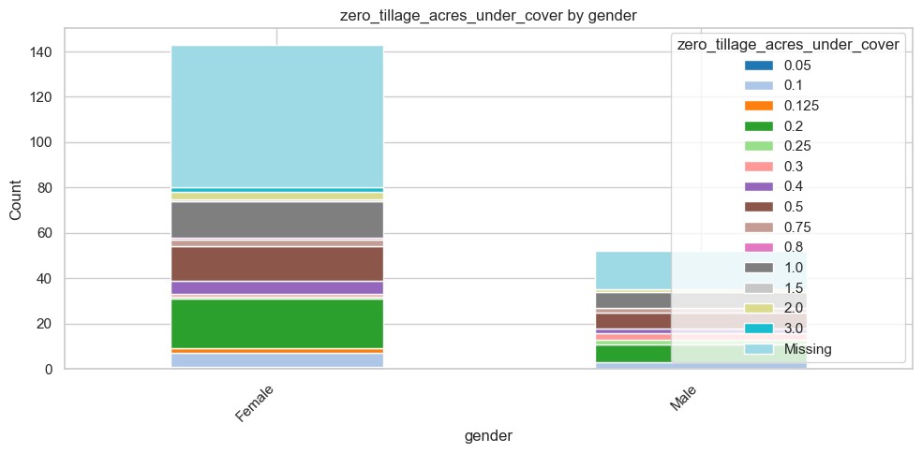
Crop rotation adopted by Age group
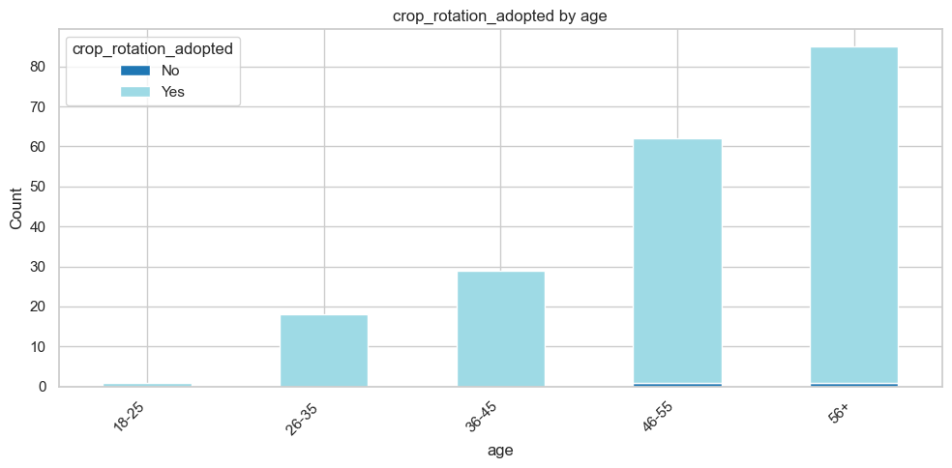
Adoption Score by Gender
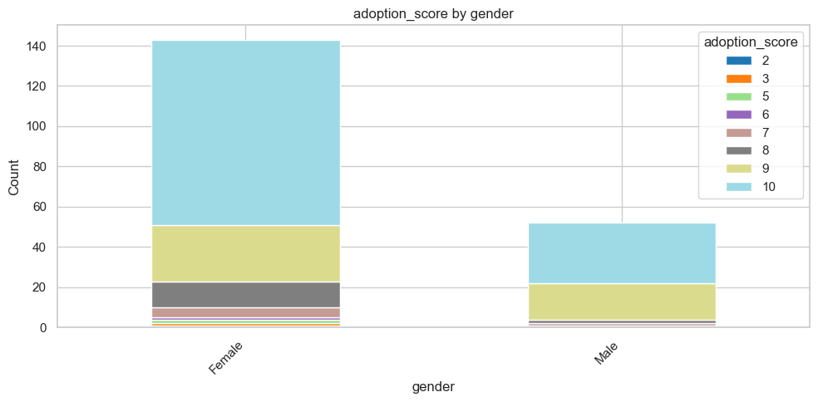
Adoption Score by Age group
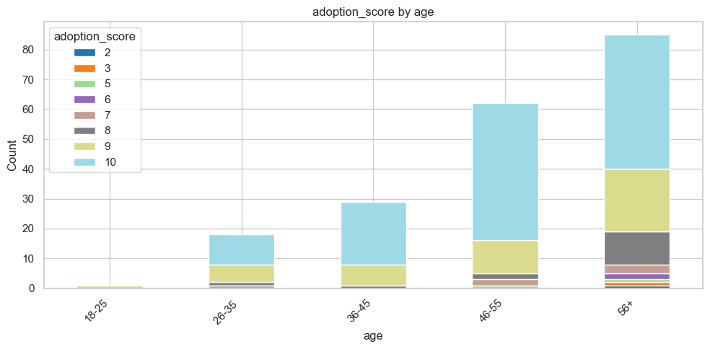

Adoption Score by Sub location
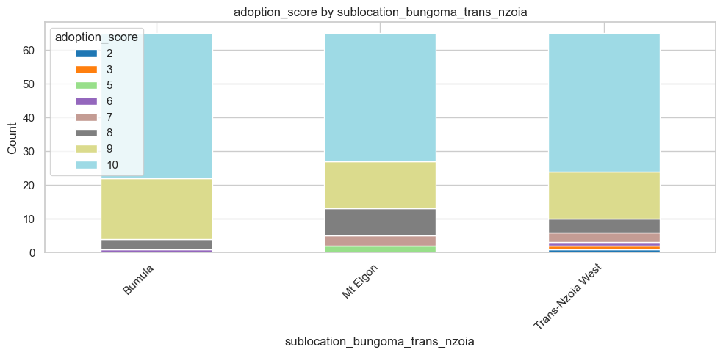

2. Scale of Implementation (Quantitative Usage)
While adoption is high, the scale of implementation varies. Female farmers show broader engagement across most practices. Older farmers (56+) and those in Bungoma County/Bumula sublocation generally implement practices on a larger scale.
Resource / Practice | Key Gender Insights | Key Age & Location Insights
Compost (Bags/Season) | Females show a wider range (common at 2, 5, 10, 20 bags). Males are more concentrated in lower (1-2 bags) and very high (50-100 bags) quantities. | Usage increases with age (46-55 & 56+ groups dominate). Bungoma has more users of 10+ bags. Bumula leads in 10-bag usage, Mt Elgon in 20-30 bag usage.
Manure (Bags/Season) | Similar to compost, females have a broader distribution. Males have a notable cluster using 20 bags/season. | The 56+ group uses the largest quantities (20+ bags). Bungoma and Bumula have significantly higher usage of 20 bags/season.
Drip Irrigation (Acres) | 1.0 acre is the most common scale for both. A significant portion of data is missing (F: 45, M: 22). | The 46-55 age group has the highest implementation. Bungoma County and Bumula sublocation show a slightly higher scale of adoption.
Mulching (Acres) | 1.0 acre is the dominant scale. Females show more diversity in smaller scales (<0.5 acres). | The 56+ group has the most farmers mulching 1.0+ acres. Bumula has a much higher number of farmers at 1.0 acre (24) than Mt Elgon (13).
Food Forest (Acres) | 1.0 acre is the most common scale for both genders. | The 56+ group is the most active. Bungoma County and Bumula sublocation have a significantly higher number of 1.0-acre food forests.
Trees Planted (Number) | A long-tail distribution. Females planted most (e.g., 5 at 300). Males planted more at the very high end (6 at 500). | The 46-55 and 56+ groups are the most prolific. Bungoma County and Bumula sublocation account for most large-scale plantings (500+ trees).

4. Enablers of Adoption
Summary: Training is the most powerful enabler. Demonstrations and Project Support are also significant. Access to Inputs is the least reported enabler, highlighting a potential resource gap.
Enabler | Gender (F=143, M=52) | Age Group | County & Sublocation
Training | F: 62%  M: 71% | Most impactful for 56+ (68%) | Trans Nzoia (66%) > Bungoma (64%).  Mt Elgon (62%) = Bumula (66%) = T-N West (66%).
Project Support | F: 50%  M: 33% | Most impactful for 36-45 (52%) | Bungoma (45%) = Trans Nzoia (46%).  Mt Elgon (48%) > Bumula (43%) = T-N West (46%).
Demonstrations | F: 52%  M: 52% | Most impactful for 56+ (53%) | Bungoma (57%) > Trans Nzoia (42%).  Mt Elgon (66%) > T-N West (42%) > Bumula (48%).
Group Support | F: 32%  M: 27% | Least reported enabler; most impactful for 56+ (34%) | Bungoma (32%) = Trans Nzoia (29%).  Mt Elgon (35%) > T-N West (29%) > Bumula (28%).
Seeing Results | F: 34%  M: 21% | Most impactful for 56+ (35%) | Bungoma (31%) = Trans Nzoia (29%).  Mt Elgon (32%) = Bumula (29%) = T-N West (29%).
Access to Inputs | F: 12%  M: 10% | Consistently low across all ages | Bungoma (12%) = Trans Nzoia (11%).  Bumula (15%) > T-N West (11%) > Mt Elgon (8%).

5. Barriers to Adoption
Summary: Cost is the predominant barrier. Climate factors and Pests are also major concerns. Knowledge is a moderate barrier, while Water Access and Conflict are lesser concerns.
Barrier | Gender (F=143, M=52) | Age Group | County & Sublocation
Cost | F: 59%  M: 50% | Most significant for 46-55 (60%) and 56+ (58%) | Bungoma (57%) = Trans Nzoia (57%).  Mt Elgon (62%) > T-N West (57%) > Bumula (52%).
Knowledge | F: 22%  M: 29% | Most significant for 56+ (31%) | Bungoma (26%) > Trans Nzoia (18%).  Bumula (29%) > Mt Elgon (23%) > T-N West (18%).
Climate | F: 36%  M: 31% | Most significant for 56+ (34%) | Trans Nzoia (38%) > Bungoma (33%).  T-N West (38%) > Mt Elgon (34%) = Bumula (32%).
Pests | F: 36%  M: 35% | Most significant for 56+ (35%) | Bungoma (40%) > Trans Nzoia (28%).  Bumula (41%) = Mt Elgon (38%) > T-N West (28%).
Water Access | F: 22%  M: 12% | Low concern, slightly higher in 26-35 (33%) | Trans Nzoia (23%) > Bungoma (17%).  T-N West (23%) > Mt Elgon (20%) > Bumula (14%).
Conflict | Negligible (1-2 farmers) | Negligible | Very low (0-3 farmers per sublocation).

6. Overall Adoption & Effect Scores
Summary: Adoption scores are high, with the majority of farmers scoring 9 or 10 out of 10. The universal effect score of zero is the core efficiency problem.
Metric | Gender | Age Group | Location & Sublocation
Adoption Score  (Out of 10) | F: 64% scored 10  M: 58% scored 10 | 56+: 53% scored 9 or 10  46-55: 92% scored 9 or 10 | Bungoma: 87% scored 9 or 10  Trans Nzoia: 85% scored 9 or 10  Bumula: 94% scored 9 or 10  Mt Elgon: 80% scored 9 or 10  T-N West: 85% scored 9 or 10
Effect Score  (Out of 10) | 0.0 for all 195 farmers | 0.0 for all 195 farmers | 0.0 for all 195 farmers

1. PRACTICE ADOPTION SUMMARY
Climate-Smart Practice | Number Adopting | Percent (%)
Agroforestry | 127 | 97.7
Drought-Tolerant Varieties | 118 | 90.8
Crop Rotation | 129 | 99.2
Mulching | 117 | 90.0
Composting | 129 | 99.2
Water Harvesting | 130 | 100.0
Drip Irrigation | 98 | 75.4
Kitchen Gardens | 129 | 99.2
Soil Conservation Structures | 121 | 93.1
Adoption levels are very high across most climate-smart practices, with water harvesting, composting, crop rotation, and kitchen gardening nearing universal uptake. Drip irrigation has comparatively lower adoption, likely due to cost or input requirements.

2. KNOWLEDGE SOURCES (Training Efficiency)
Source of Knowledge/Training | Respondents | Percent (%)
DESECE Demonstration Plots | 4 | 3.1
DESECE Trainings | 126 | 96.9
Other NGO Trainings | 0 | 0.0
Government Officers | 3 | 2.3
Media (Radio/TV) | 9 | 6.9
Family/Relatives | 6 | 4.6
Neighbors/Peers | 8 | 6.2
The DESECE project is the primary source of climate-smart agriculture knowledge, demonstrating strong program reach and training effectiveness. External sources contribute minimally.

3. INTENSITY / SCALE OF USE
Practice / Input Use | Average Use per Household
Compost (bags per season) | 12.88
Manure (bags per season) | 11.47
Cover Crops (acres) | 0.64
Zero Tillage (acres) | 0.58
Crop Rotation (acres) | 0.71
Compost and manure use are widely applied in substantial quantities. Land under conservation practices (cover crops, zero tillage, crop rotation) is moderate but suggests consistent integration into farming routines.

4. PERCEIVED EFFECTIVENESS OF PRACTICES
General Pattern:
Across nearly all practices, the majority of farmers report “Very Positive” effects, particularly in:
- Composting and manure application
- Crop rotation and cover cropping
- Kitchen gardens and intercropping
- Drought-tolerant varieties
- Rainwater harvesting
Lower perceived effectiveness / higher uncertainty appears mainly in zero tillage and drip irrigation, which may reflect technical challenges, cost, or variable suitability.

5. CONTINUATION / SUSTAINABILITY
Response | Percent (%)
Definitely Yes | 97.7
Probably Yes | 2.3
The continuation intention is extremely high, indicating that practices are both valuable and feasible for households to sustain beyond the project.

Phase 3: Analytical Framework by Evaluation Question

EQ 5 & 6: Sustainability – Likelihood of Continuation

B6. For each of the practices you are currently using, how would you rate its effect on your farm?
D1. Do you think the new farming practices you are using are better than your old ones?
D2. Do you plan to continue using these practices in the next growing season?
D3. What might stop you from continuing?
D4. How actively is your farmer group functioning now?
D5. Does the group have a plan to continue without project support?
D6. Where will you go for advice or help with farming problems now?

B6. For each of the practices you are currently using, how would you rate its effect on your farm?

B6: Perceived Effectiveness of Practices
b6_practice_effectiveness_summary
Practice | Very Positive | Somewhat Positive | Neutral/Negative | Not Applicable
Composting | 188 (96.4%) | 3 (1.5%) | 2 (1.0%) | 2 (1.0%)
Manure Use | 184 (94.4%) | 3 (1.5%) | 2 (1.0%) | 6 (3.1%)
Kitchen Garden | 191 (98.0%) | 2 (1.0%) | 1 (0.5%) | 1 (0.5%)
Food Forest | 180 (92.3%) | 8 (4.1%) | 1 (0.5%) | 6 (3.1%)
Crop Rotation | 172 (88.2%) | 18 (9.2%) | 3 (1.5%) | 2 (1.0%)
Rainwater Harvesting | 175 (89.7%) | 19 (9.7%) | 0 (0.0%) | 1 (0.5%)
Cover Crops | 177 (90.8%) | 12 (6.2%) | 5 (2.6%) | 1 (0.5%)
Early Varieties | 176 (90.3%) | 16 (8.2%) | 2 (1.0%) | 1 (0.5%)
IPM | 152 (77.9%) | 21 (10.8%) | 5 (2.6%) | 17 (8.7%)
Mulching | 164 (84.1%) | 10 (5.1%) | 3 (1.5%) | 18 (9.2%)
Trees | 167 (85.6%) | 15 (7.7%) | 9 (4.6%) | 4 (2.1%)
Drip Irrigation | 107 (54.9%) | 34 (17.4%) | 11 (5.6%) | 43 (22.1%)
Zai Pits | 107 (54.9%) | 26 (13.3%) | 11 (5.6%) | 51 (26.2%)
Zero Tillage | 96 (49.2%) | 37 (19.0%) | 12 (6.2%) | 50 (25.6%)
Vegetation Strips | 114 (58.5%) | 28 (14.4%) | 6 (3.1%) | 47 (24.1%)

Key Effectiveness Patterns by County
- Bungoma County: Consistently shows 1-3% higher "Very Positive" ratings across most practices
- Trans Nzoia County: Slightly lower effectiveness ratings, particularly for soil conservation practices
- Age Group Patterns:
- 46-55 and 56+ age groups: Show highest effectiveness ratings across all practices
- Younger farmers (18-45): Report slightly lower but still very positive effectiveness
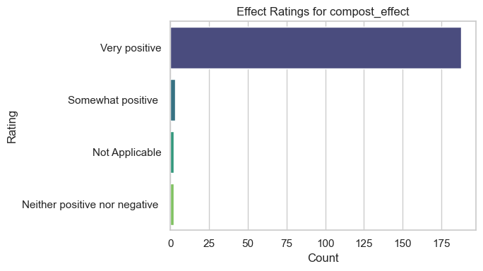

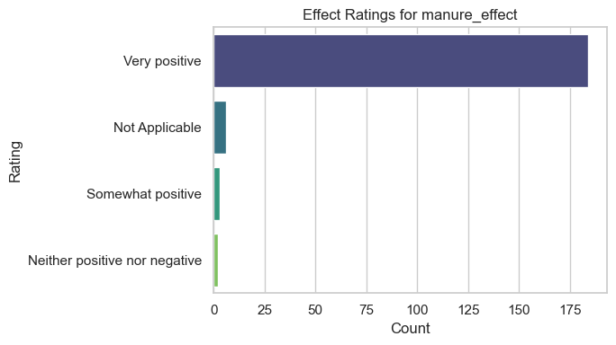

D1. Do you think the new farming practices you are using are better than your old ones?

D1: Practice Superiority Perception
d1_practice_superiority_overall
Perception | Count | Percentage
Yes, much better | 182 | 93.3%
Yes, a little better | 11 | 5.6%
About the same | 2 | 1.0%

d1_practice_superiority_by_demographic
Demographic | Much Better | Little Better | About Same
Gender
Female | 133 (93.0%) | 7 (4.9%) | 3 (2.1%)
Male | 49 (94.2%) | 3 (5.8%) | 0 (0.0%)
County
Bungoma | 123 (94.6%) | 5 (3.8%) | 2 (1.5%)
Trans Nzoia | 59 (90.8%) | 5 (7.7%) | 1 (1.5%)
Age Group
18-25 | 0 (0%) | 0 (0%) | 0 (0%)
26-35 | 0 (0%) | 0 (0%) | 0 (0%)
36-45 | 28 (96.6%) | 1 (3.4%) | 0 (0.0%)
46-55 | 56 (90.3%) | 5 (8.1%) | 1 (1.6%)
56+ | 85 (100.0%) | 0 (0.0%) | 0 (0.0%)

D2. Do you plan to continue using these practices in the next growing season?

D2: Continuation Intentions
d2_continuation_intentions_overall
Intention | Count | Percentage
Definitely yes | 184 | 94.4%
Probably yes | 10 | 5.1%
Probably not | 1 | 0.5%

d2_continuation_intentions_by_demographic
Demographic | Definitely Yes | Probably Yes | Probably Not
Gender
Female | 134 (93.7%) | 8 (5.6%) | 1 (0.7%)
Male | 50 (96.2%) | 2 (3.8%) | 0 (0.0%)
County
Bungoma | 124 (95.4%) | 5 (3.8%) | 1 (0.8%)
Trans Nzoia | 60 (92.3%) | 5 (7.7%) | 0 (0.0%)
Age Group
18-25 | 0 (0%) | 0 (0%) | 0 (0%)
26-35 | 0 (0%) | 0 (0%) | 0 (0%)
36-45 | 28 (96.6%) | 1 (3.4%) | 0 (0.0%)
46-55 | 57 (91.9%) | 5 (8.1%) | 0 (0.0%)
56+ | 81 (95.3%) | 3 (3.5%) | 1 (1.2%)
D3. What might stop you from continuing?

D3: Barriers to Continuation
d3_barriers_to_continuation_overall
Barrier | Count | Percentage
No barriers | 134 | 68.7%
Lack of money | 44 | 22.6%
Equipment breaks | 30 | 15.4%
No market for produce | 19 | 9.7%
No access to advice | 7 | 3.6%
Other barriers | 4 | 2.1%
Lack of labor | 3 | 1.5%
d3_barriers_by_demographic (Top Barriers)
Demographic | No Barriers | Lack of Money | Equipment Issues
Gender
Female | 98 (68.5%) | 33 (23.1%) | 23 (16.1%)
Male | 36 (69.2%) | 11 (21.2%) | 7 (13.5%)
Age Group
56+ | 63 (74.1%) | 25 (29.4%) | 18 (21.2%)
46-55 | 44 (71.0%) | 14 (22.6%) | 5 (8.1%)
36-45 | 21 (72.4%) | 4 (13.8%) | 4 (13.8%)
26-35 | 0 (0%) | 0 (0%) | 0 (0%)
18-25 | 0 (0%) | 0 (0%) | 0 (0%)
D4. How actively is your farmer group functioning now?

D4: Farmer Group Functionality
d4_group_functionality_overall
Functionality Level | Count | Percentage
Very active | 150 | 76.9%
Somewhat active | 41 | 21.0%
Not active | 3 | 1.5%
No longer together | 1 | 0.5%
d4_group_functionality_by_demographic
Demographic | Very Active | Somewhat Active | Not Active
Gender
Female | 109 (76.2%) | 31 (21.7%) | 3 (2.1%)
Male | 41 (78.8%) | 10 (19.2%) | 1 (1.9%)
County
Bungoma | 102 (78.5%) | 26 (20.0%) | 2 (1.5%)
Trans Nzoia | 48 (73.8%) | 15 (23.1%) | 2 (3.1%)
D5. Does the group have a plan to continue without project support?

D5: Group Sustainability Plans
d5_group_sustainability_plans_overall
Plan Status | Count | Percentage
Clear plan | 138 | 70.8%
Unclear plan | 35 | 17.9%
No plan | 17 | 8.7%
Don't know | 5 | 2.6%

d5_group_plans_by_demographic
Demographic | Clear Plan | Unclear Plan | No Plan
Gender
Female | 101 (70.6%) | 26 (18.2%) | 16 (11.2%)
Male | 37 (71.2%) | 9 (17.3%) | 6 (11.5%)
Age Group
18-25 | 0 (0%) | 0 (0%) | 0 (0%)
26-35 | 0 (0%) | 0 (0%) | 0 (0%)
36-45 | 0 (0%) | 0 (0%) | 0 (0.0%)
46-55 | 46 (74.2%) | 11 (17.7%) | 5 (8.1%)
56+ | 68 (80.0%) | 8 (9.4%) | 9 (10.6%)
D6. Where will you go for advice or help with farming problems now?

D6: Future Sources of Advice
d6_future_advice_sources_overall
Source | Count | Percentage
Farmer group | 178 | 91.3%
Other farmers | 29 | 14.9%
Other sources | 18 | 9.2%
Government | 11 | 5.6%
Agro-dealer | 8 | 4.1%
Don't know | 4 | 2.1%
d6_advice_sources_by_demographic
Demographic | Farmer Group | Other Farmers | Government
Gender
Female | 131 (91.6%) | 23 (16.1%) | 9 (6.3%)
Male | 47 (90.4%) | 6 (11.5%) | 2 (3.8%)
Age Group
18-25 | 0 (0%) | 0 (0%) | 0 (0%)
26-35 | 0 (0%) | 0 (0%) | 0 (0%)
36-45 | 0 (0%) | 0 (0%) | 0 (0.0%)
46-55 | 58 (93.5%) | 12 (19.4%) | 4 (6.5%)
56+ | 75 (88.2%) | 14 (16.5%) | 8 (9.4%)

Phase 3: Analytical Framework by Evaluation Question

EQ 7: Generate Learning – Future Support
D7. What should a future project focus on for bigger impact?
E4. What specific support does your group need to be self-reliant?
E1. What was the most effective part of the project?
E2a. What was the least effective or most challenging part?

E1. What was the most effective part of the project? (proj_effective_part)

Most Effective Parts of the Project
Rank | Component | Percent (%)
1 | The practical, on-farm training | 50.0
2 | The demonstration farms | 29.2
3 | Support for irrigation/water | 8.5
4 | Group approach (farmer groups) | 7.7
5 | Quality of project staff | 4.6

--- Most Effective part by GENDER ---
Gender | Practical, On-Farm Training | Demonstration Farms | Group Approach | Project Staff Quality | Support for Irrigation
Female (n=143) | 76 (53.1%) | 37 (25.9%) | 10 (7.0%) | 8 (5.6%) | 11 (7.7%)
Male (n=52) | 24 (46.2%) | 17 (32.7%) | 2 (3.8%) | 3 (5.8%) | 5 (9.6%)
Interpretation | Practical training is the top choice for both genders, but a higher proportion of women value it. Men show relatively higher appreciation for demonstration farms.
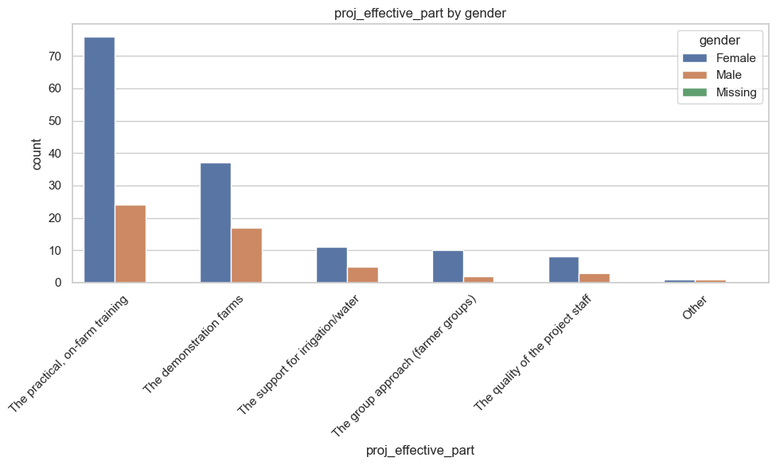

--- Most Effective part By AGE GROUP ---
Age Group | Practical, On-Farm Training | Demonstration Farms
18-25 (n=1) | 1 (100%) | 0
26-35 (n=18) | 0 | 0
36-45 (n=29) | 17 (58.6%) | 8 (27.6%)
46-55 (n=62) | 33 (53.2%) | 21 (33.9%)
56+ (n=85) | 39 (45.9%) | 20 (23.5%)
Interpretation | Practical training is the most valued across all age groups, with the highest emphasis from the 36-55 cohort. The 26-35 group shows no data for this question.

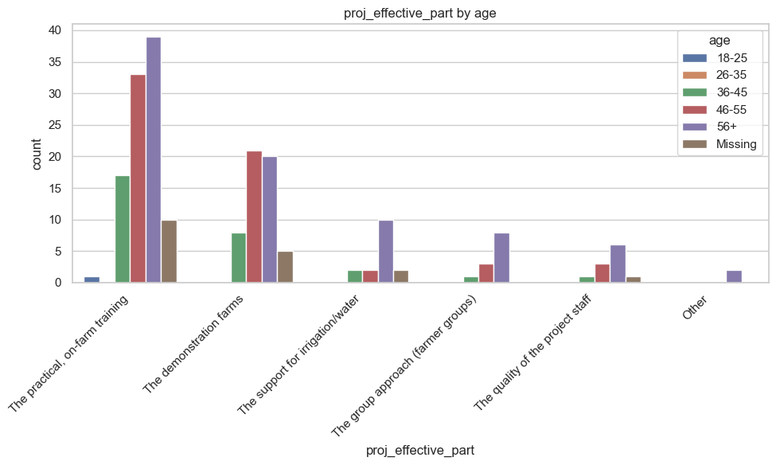

--- Most Effective part By COUNTY ---
County | Practical, On-Farm Training | Demonstration Farms | Support for Irrigation
Bungoma (n=130) | 65 (50.0%) | 38 (29.2%) | 11 (8.5%)
Trans Nzoia (n=65) | 35 (53.8%) | 16 (24.6%) | 5 (7.7%)
Interpretation | Consistently, practical training is the top choice in both counties, with very similar appreciation levels.

--- Most Effective part By SUBLOCATION ---
Sublocation | Practical, On-Farm Training | Demonstration Farms
Bumula (n=65) | 31 (47.7%) | 18 (27.7%)
Mt Elgon (n=65) | 34 (52.3%) | 20 (30.8%)
Trans-Nzoia West (n=65) | 35 (53.8%) | 16 (24.6%)
Interpretation | All three sublocations overwhelmingly favor practical, on-farm training as the most effective component.

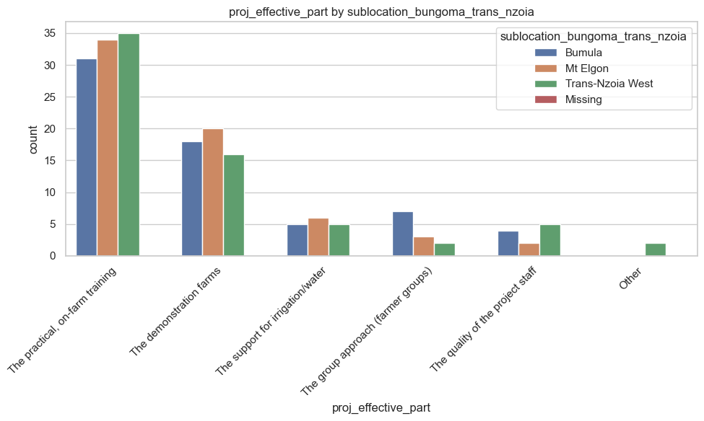

--- Most Effective part By BENEFICIARY STATUS ---
Beneficiaries (n=195): The most effective part was Practical, On-Farm Training (100 respondents), followed by Demonstration Farms (54).
Interpretation: The project's hands-on, practical approach was universally identified as its greatest strength by those who directly benefited from it.

E2a. What was the least effective or most challenging part? (proj_least_effective_part)
--- Least Effective part By GENDER ---
Gender | Inputs Delivered Late | Group Management Difficult | Not Enough Follow-up | Training Too Theoretical
Female (n=143) | 30 (21.0%) | 39 (27.3%) | 14 (9.8%) | 13 (9.1%)
Male (n=52) | 18 (34.6%) | 9 (17.3%) | 10 (19.2%) | 4 (7.7%)
Interpretation | Logistics (late inputs) and group dynamics were the top challenges. Men reported late inputs as a bigger issue, while women found group management more challenging.

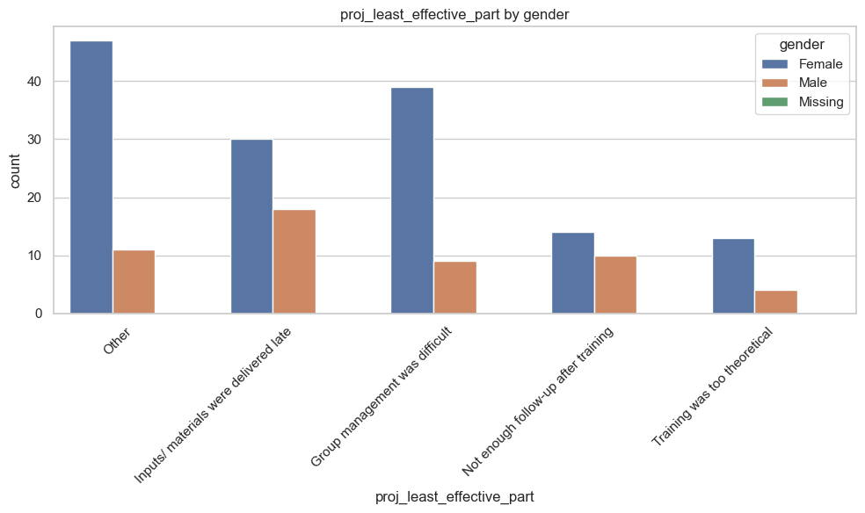
--- Least Effective part By AGE GROUP ---
Age Group | Inputs Delivered Late | Group Management Difficult
18-25(n=1) | 0 (0%) | 0 (0%)
26-35 (n=18) | 34 (30.3%) | 14 (25.3%)
36-45 (n=29) | 6 (20.7%) | 6 (20.7%)
46-55 (n=62) | 18 (29.0%) | 16 (25.8%)
56+ (n=85) | 17 (20.0%) | 24 (28.2%)
Interpretation | Challenges are reported across all age groups. The 46-55 group was most concerned with late inputs, while the 56+ group found group management most difficult.

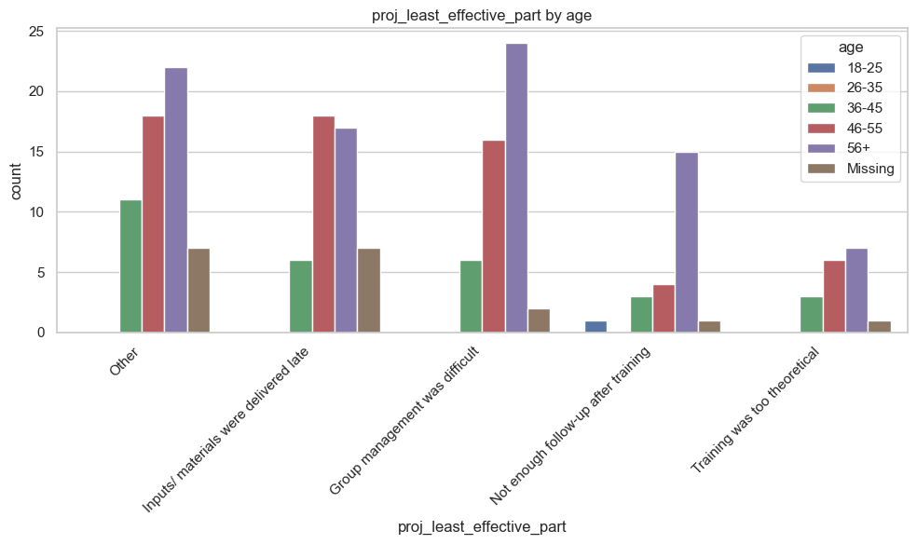

--- Least Effective part By COUNTY ---
County | Inputs Delivered Late | Group Management Difficult | Not Enough Follow-up
Bungoma (n=130) | 32 (24.6%) | 32 (24.6%) | 23 (17.7%)
Trans Nzoia (n=65) | 16 (24.6%) | 16 (24.6%) | 1 (1.5%)
Interpretation | The distribution of challenges is remarkably similar between counties for inputs and group management. However, follow-up was a much more significant concern in Bungoma.
--- Least Effective part By SUBLOCATION ---
Sublocation | Inputs Delivered Late | Group Management Difficult | Not Enough Follow-up
Bumula (n=65) | 18 (27.7%) | 12 (18.5%) | 10 (15.4%)
Mt Elgon (n=65) | 14 (21.5%) | 20 (30.8%) | 13 (20.0%)
Trans-Nzoia West (n=65) | 16 (24.6%) | 16 (24.6%) | 1 (1.5%)
Interpretation | Mt Elgon struggled most with group management, while Bumula had the highest issue with late inputs. The lack of follow-up was a pronounced issue in Bumula and Mt Elgon but barely registered in Trans-Nzoia West.
--- Least Effective part By BENEFICIARY STATUS ---
Beneficiaries (n=195): The main challenges were Inputs/Materials Delivered Late (48) and Group Management was Difficult (48), followed by Not Enough Follow-up (24).
Interpretation: For beneficiaries, logistical delays and social challenges in group management were the primary hurdles, underscoring the importance of efficient supply chains and strong group facilitation.

D7. What should a future project focus on for bigger impact? (future_project_focus_list)
(Analysis based on the most frequent single and combined responses)
--- Future project focus By GENDER ---
Priority | Female | Male
Advanced Business Training | 8 | 6
Access to Loans/Credit | 10 | 3
Better Market Access | (Frequently combined) | (Frequently combined)
Interpretation | Both genders prioritize business skills and finance, but women show a notably higher demand for access to credit.
--- Future project focus By AGE GROUP ---
Age Group | Top Focus Areas
18-25 | Youth-specific programs
26-35 | Business Training, Access to Loans
36-45 | Access to Loans, Business Training
46-55 | Business Training, Access to Loans
56+ | Business Training, Access to Loans, Better Market Access
Interpretation | The demand for business skills and capital increases with age, with the oldest farmers (56+) being the most vocal about needing business training.

--- Future project focus By COUNTY ---
County | Top Focus Areas
Bungoma | Advanced Business Training (9), Access to Loans/Credit (7)
Trans Nzoia | Access to Loans/Credit (6), Advanced Business Training (5)
Interpretation | Both counties have aligned priorities, with a strong, equal demand for business skills and financial products to scale their enterprises.
--- Future project focus By BENEFICIARY STATUS ---
Beneficiaries (n=195): The top requests for a future project are Advanced Business Training (14), Access to Loans/Credit (13), and Better Market Access (2 - as a single mention, but frequently combined).
Interpretation: Beneficiaries are clearly looking to move from production to entrepreneurship, seeking the skills and capital to become more commercially oriented.

E4. What specific support does your group need to be self-reliant? (supports_needed_list)
--- Support needed list By GENDER ---
Support Needed | Female | Male
Stronger Links to Buyers/Markets | 16 | 6
A Grant/Loan for Group Enterprise | 17 | 9
Advanced Business Training | 8 | 6
Interpretation | While both genders need market links and capital, women emphasize market access slightly more, while men have a stronger focus on start-up grants/loans.
--- Support needed list By AGE GROUP ---
Age Group | Top Support Needs
18-25 | Advanced business training
26-35 | Market Links, Grants/Loans
36-45 | Grants/Loans, Market Links
46-55 | Market Links, Grants/Loans
56+ | Market Links, Grants/Loans
Interpretation | Market linkages are the paramount need for older farmers (46+), while all groups see access to capital as a critical second priority.

--- Support needed list By COUNTY ---
County | Top Support Needs
Bungoma | Stronger Links to Buyers/Markets (15), A Grant/Loan (13)
Trans Nzoia | A Grant/Loan (13), Stronger Links to Buyers/Markets (7)
Interpretation | Bungoma groups are more focused on securing buyers, while Trans Nzoia groups prioritize accessing start-up capital, though both are critical for both counties.

--- Support needed list By SUBLOCATION ---
Sublocation | Top Support Needs
Bumula | A Grant/Loan (7), Business Training (8)
Mt Elgon | Stronger Links to Buyers/Markets (12), A Grant/Loan (6)
Trans-Nzoia West | A Grant/Loan (13), Stronger Links to Buyers/Markets (7)
Interpretation | Needs vary significantly by sublocation. Mt Elgon's primary need is market access, Trans-Nzoia West's is capital, and Bumula has a balanced need for both capital and business training.

